

**UNIVERSITY OF GREENWICH**  
COMP1786 – Mobile Application Design and Development

Coursework

|  |  |
| --- | --- |
| Student name | Huu Duy Do |
| ID number (00xxxxxxx) | 001353267 |
| Lecturer/Tutor name | Thai Huy Le |
| Student submission date | 22/11/2023 |

Table of Contents

1. Introduction 4

2. Brief Statement of Features I Have Implemented 4

3. Function 4

3.1. ERD Diagram 4

3.2. Mockup 5

3.3. Technology used in my project 7

4. Screen Shots/Design 7

5. Evaluate the application 22

6. Conclusion 22

References 23

Appending A - Steps to perform adding environment variables to run the application 24

**Table of Figures**

Figure 1. ERD Diagram 5

Figure 2. Login page mockup 5

Figure 3. Register page mockup 5

Figure 4. Homepage mockup 6

Figure 5. List hikes page mockup 6

Figure 6. Add a new hike page mockup 6

Figure 7. Add a new observation mockup 6

Figure 8. Profile page mockup 7

Figure 9. Intro page 8

Figure 10. The code of the intro page is line 14 8

Figure 11. The code of the intro page is line 16-30 8

Figure 12. The code of the intro page is line 43-40 8

Figure 13. Register page 9

Figure 14. The code of the register page is line 12-31 9

Figure 15. Login page 10

Figure 16. The code of the login page is line 13-32 10

Figure 17. Homepage 11

Figure 18. The code of the homepage is line 77-78 11

Figure 19. The code of the homepage is line 83-90 11

Figure 20. The code of the homepage is line 95-97 11

Figure 21. The code of the homepage is line 99-120 12

Figure 22. The code of the homepage is line 122-146 12

Figure 23. Add a new hike page 13

Figure 24. The code of the add hike page is line 72-79 13

Figure 25. The code of the add hike page is line 115-122 13

Figure 26. The code of the add hike page is line 137-143 13

Figure 27. The code of the add hike page is line 144-149 14

Figure 28. The code of the add hike page is line 182-188 14

Figure 29. List hike page and view detail hike page 14

Figure 30. Edit function, share function, search function, and delete function 14

Figure 31. The code of the list page is line 93-97 14

Figure 32. The code of the list page is line124-127 15

Figure 33. The code of the list page is line135-140 15

Figure 34. The code of the list page is line 173-175 15

Figure 35. The code of the list page is line 190-202 15

Figure 36. The code of the list page is line 359-368 15

Figure 37. The code of the list page is line 440-446 15

Figure 38. The code of the list page is line 448-451 15

Figure 39. Add a new observation function 16

Figure 40. The code of the observation page is line 62-69 16

Figure 41. The code of the observation page is line 71-78 16

Figure 42. The code of the observation page is line 80-84 16

Figure 43. The code of the observation page is line 86-93 17

Figure 44. The code of the observation page is line 116-120 17

Figure 45. The code of the observation page is line 122-126 17

Figure 46. The code of the observation page is line 148-154 17

Figure 47. The code of the observation page is line 156-162 17

Figure 48. The code of the observation page is line 164-169 17

Figure 49. The code of the observation page is line 172-177 17

Figure 50. The code of the observation page is line 179-187 18

Figure 51. The code of the observation page is line 199-202 18

Figure 52. The code of the observation page is line 287-292 18

Figure 53. Update and delete observation function 18

Figure 54. The code of the observation function is line 57-64 18

Figure 55. The code of the observation function is line 66-73 19

Figure 56. The code of the observation function is line 75-81 19

Figure 57. The code of the observation function is line 83-87 19

Figure 58. The code of the observation function is line 89-91 19

Figure 59. The code of the observation function is line 105-108 19

Figure 60. The code of the observation function is line 126, 140, and 147 19

Figure 61. The code of the observation function is line 158-161 19

Figure 62. The code of the observation function is line 237-240 19

Figure 63. The code of the observation function is line 286-288 19

Figure 64. The code of the observation function is line 290-296 20

Figure 65. Profile page and edit profile function 20

Figure 66. Change password function 20

Figure 67. The code of the profile page is line 65-72 20

Figure 68. The code of the profile page is line 75-81 21

Figure 69. The code of the profile page is line 83-89 21

Figure 70. The code of the profile page is line 92-95 21

Figure 71. The code of the profile page is line 97-98 21

Figure 72. The code of the profile page is line 106-108 21

Figure 73. The code of the profile page is line 150-153 21

Figure 74. The code of the profile page is line 204-207 21

Figure 75. The code of the profile page is line 282-285 21

Figure 76. The code of the profile page is line 367-370 21

Figure 77. The code of the profile page is line 389-395 22

Figure 78. The code of the profile page is line 397-400 22

Figure 79. JTDS library 24

Figure 80. Copy JTDS file 24

Figure 81. Paste the JTDS library to project 24

Figure 82. Path of libs in project 24

Figure 83. Performing apply the JTDS 25

Figure 84. Performing apply the JTDS 25

Figure 85. Paste the path just copy before 25

Figure 86. JTDS that applied succeed 25

Figure 87. Connect database 26

**Table of Tables**

Table 1: The checklist of application features 4

2. **Introduction**

An overview of a particular application, targeted at climbing enthusiasts, is given in this coursework. The application blends technology with the spirit of exploration, providing special features, thoughtful design, and looks at the development process. Providing information on security protocols, adaptability to various screen sizes, human-computer interaction, and live deployment considerations is the aim. With the team having three members, we created the app "DHT Ranger" to tackle the difficulties that mountaineers encounter. With the help of Android Studio, we developed a strong app that improves climbing and caters to a variety of enthusiast needs.

This report is separated into 6 parts. Part 1, we will introduce an overview of the project. Part 2, we will describe the features of the application. Part 3 is the mockup and diagram of the app and some of technical use to develop the application. Part 4, we will show the screenshot of the app’s UI and explanation code. Part 5, we will evaluate the application that we developed. Part 6 is the conclusion of this report.

1. **Brief Statement of Features I Have Implemented**

The requirements and functionality of our application were assessed using the input screen checklist, as shown in the table below:

Table 1: The checklist of application features

|  |  |  |  |
| --- | --- | --- | --- |
| **No.** | **Objective** | **Functions** | **Implemented** |
| 1 | Hike | Add a new hike | Fully implemented |
| Edit a hike | Fully implemented |
| Delete a hike | Fully implemented |
| View all hikes | Fully implemented |
| View detail hike | Fully implemented |
| Share hike | Fully implemented – Extra function |
| Search hike | Fully implemented |
| 2 | Observation | Add a new observation | Fully implemented |
| Edit an observation | Fully implemented |
| Delete an observation | Fully implemented |
| View all observation | Fully implemented |
| View detail observation | Fully implemented |
| Search observation | Fully implemented – Extra function |
| 3 | Authentication | Login | Fully implemented – Extra function |
| Register | Fully implemented – Extra function |
| View hikes that other people have shared | Fully implemented – Extra function |
| View detailed hike from other hikers | Fully implemented – Extra function |
| Edit profile | Fully implemented – Extra function |
| Change password | Fully implemented – Extra function |
| Log out | Fully implemented – Extra function |

1. **Function**
   1. **ERD Diagram**

Below is the ERD diagram, presenting the relationships of the DHT Ranger application designed and develop in Microsoft SQL Server 2022.

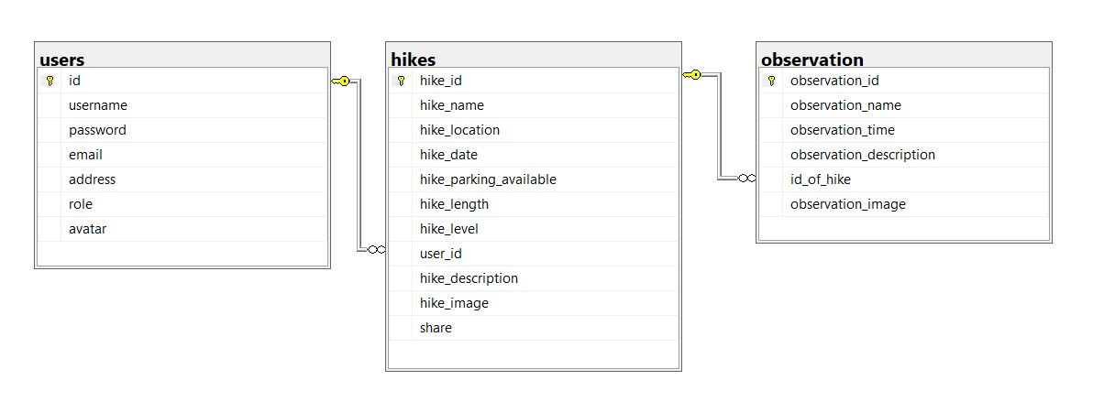

Figure 1. ERD Diagram

* 1. **Mockup**

Below is the mockup of the DHT Ranger application, designed to support for develop the application.

* **Login page:**

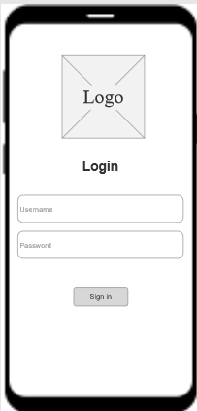

Figure 2. Login page mockup

* **Register page:**

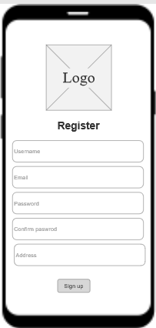

Figure 3. Register page mockup

* **Home page:**

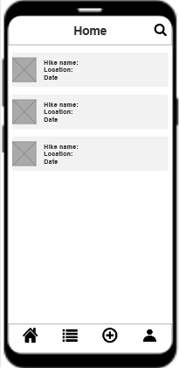

Figure 4. Homepage mockup

* **List hikes page:**

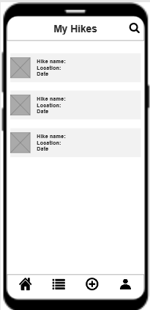

Figure 5. List hikes page mockup

* **Add a new hike page:**

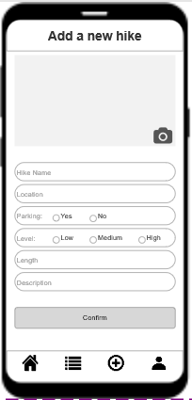

Figure 6. Add a new hike page mockup

* **Add a new observation page:**

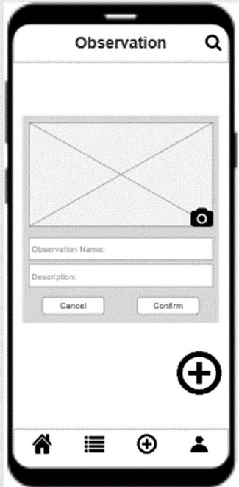

Figure 7. Add a new observation mockup

* **Profile page:**

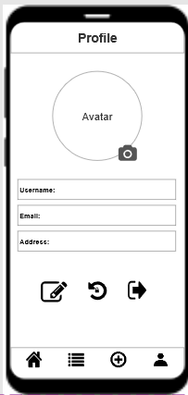

Figure 8. Profile page mockup

* 1. **Technology used in my project**
* **Android studio**

Google developed Android Studio; an integrated development environment (IDE) specifically meant for creating mobile applications for the Android operating system. Using Android Studio for our project, which is to create a mobile application for mountain climbers, enables us to make efficient use of resources and tools to create an application that is appropriate for the Android platform. It assists in meeting the unique requirements of those who engage in mountain climbing activities (DiMarzio, 2016).

* **SQL server**

According to (Ward, 2019), Large-scale query and data processing in Microsoft SQL Server 2022. Large data clusters, support for PolyBase, more intelligent query processing, enhanced security, support for Kubernetes, and reusable online index rebuilds are some of the main improvements.

SQL Server is utilized in our project as the database solution for our Android Studio application, offering a strong basis for managing and storing data. In our application, SQL Server is an effective tool for managing and organizing data. It supports complex queries, improves system security with data encryption and access control, and enables the smooth execution of CRUD operations. It guarantees consistency across devices by streamlining data synchronization between the database and the mobile application. An advantage of SQL Server is that it provides resources, community insights, and online support. The efficiency of the application is increased by Android Studio's integration with SQL Server via libraries like JDBC or Retrofit.

* **Java language**

Sun Microsystems created Java, a programming language that is readable and adaptable (now part of Oracle). Java's flexibility and mobility make it possible for developers to create efficient Android applications, which is relevant to the project involving the creation of a mobile application for mountain climbers. Java is widely used in mobile app development because of its robust community support, high-security features, and wide compatibility (James Gosling, 2005).

1. **Screen Shots/Design**

Below are Screenshots of the design and code to describe our project. To execute the project, you must have "Hikes" data on the SQL Server to run the application. We have shown the steps to add a database in the Appending A part.

* **Intro page:** The introduction page will load when the user launches the program. The user can choose between the "Sign in" and "Sign up" buttons in it to access the application.

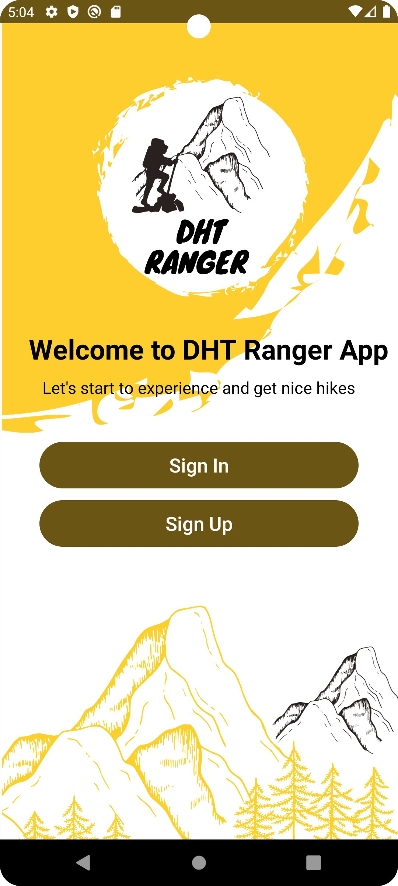

Figure 9. Intro page

* **Explanation of the code of the intro page:**

Two private Button variables (btnSignUp and btnSignIn) are declared to reference the buttons in the layout.



Figure 10. The code of the intro page is line 14

The overrides the onCreate method. Upon creating the activity, this method is invoked. setContentView(R.layout.activity_intro); sets the activity's content view to the layout specified in the activity_intro XML file. To initialize the two buttons (btnSignIn and btnSignUp), locate them in the layout using their corresponding IDs. We have configured a click listener for the "Sign Up" button. Clicking the "Sign Up" button initiates the SignUp activity by creating an intent. The transition to the Signups activity is started by the startActivity(intent).

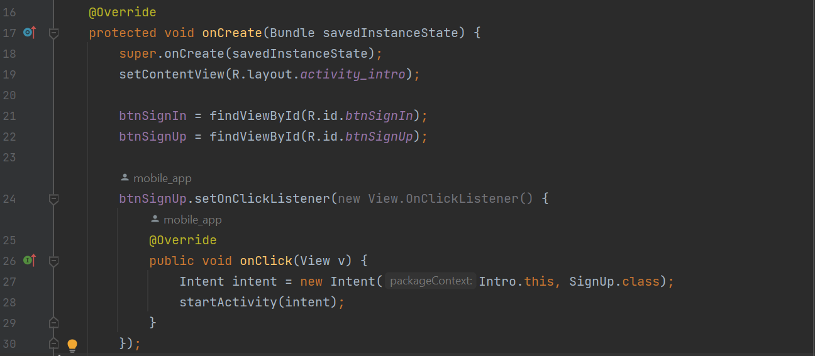

Figure 11. The code of the intro page is line 16-30

Similarly, a click listener is set for the "Sign In" button. When the "Sign In" button is clicked, it creates an Intent to start the SignIn activity. The startActivity(intent); line initiates the transition to the SignIn activity.

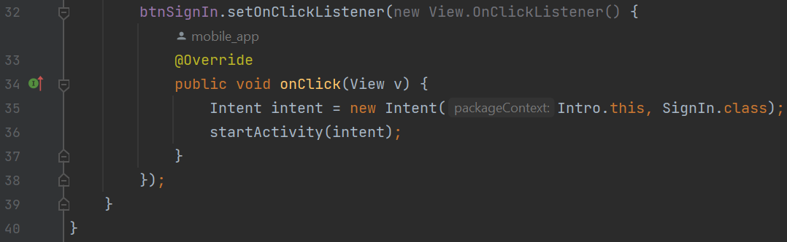

Figure 12. The code of the intro page is line 43-40

* **Register page:** The user will be taken directly to the registration page when they click on the "Sign up" button. Users are required to provide registration details, including address, email address, password, and username. If incorrect data is entered, the system will notify the user of the error by displaying an exception message as soon as possible. When the users sign up succeed it will redirect to the login page.

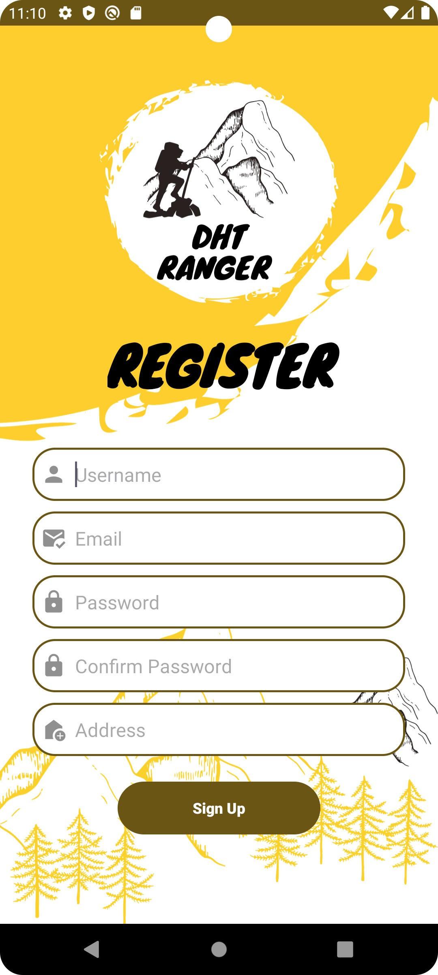 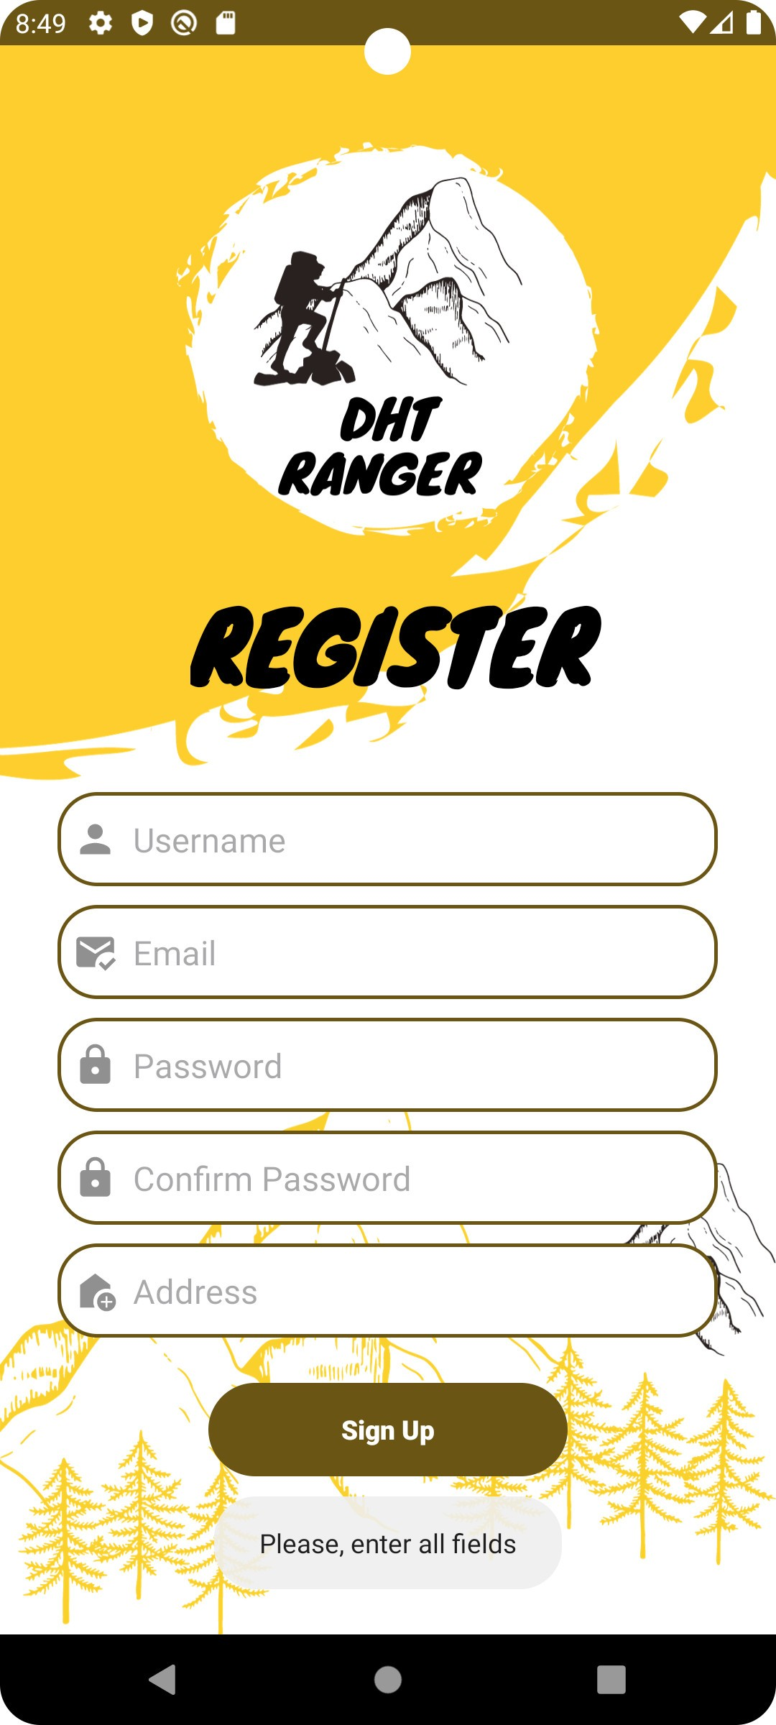

Figure 13. Register page

* **Explanation of the code of the register page:**

A click listener is set for the "Sign Up" button (btnSignUp). An intent to initiate the SignIn activity is created when the "Sign Up" button is clicked. The transition to the SignUp activity is started by the startActivity(intent) line. It is configured to listen for clicks on the "Sign Up" button (btnSignUp). An intent to initiate the SignUp activity is created when the "Sign Up" button is clicked. The transition to the SignUp activity is started by the startActivity(intent) line.

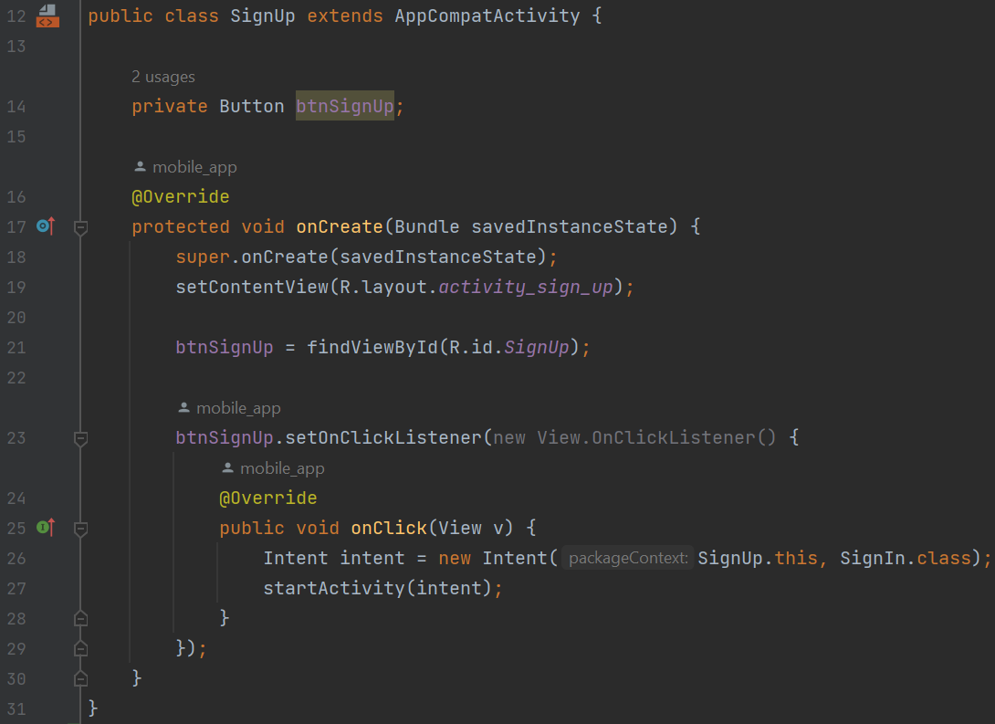

Figure 14. The code of the register page is line 12-31

* **Login page:** When users click the "Sign in" button, they will be taken to the login page, where they can authenticate themselves using the password and username they have signed up before, which are associated with their individual accounts. Exception messages will appear in the event that an incorrect entry is made; if not, the user will be taken to the home page.

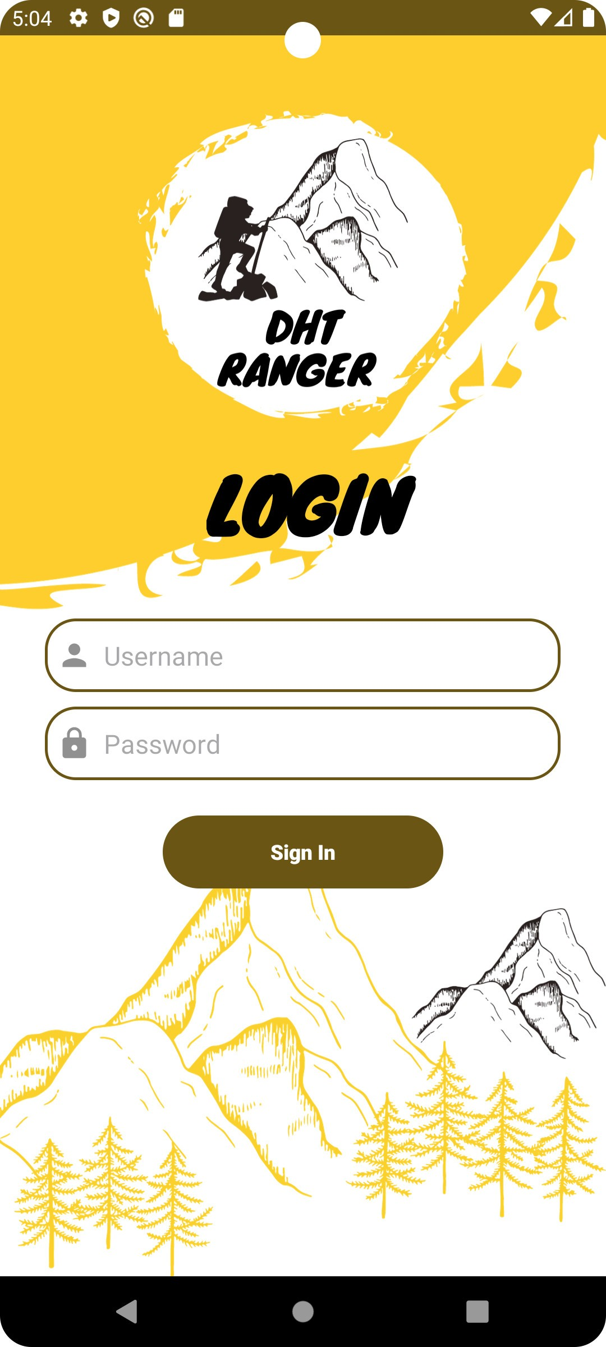 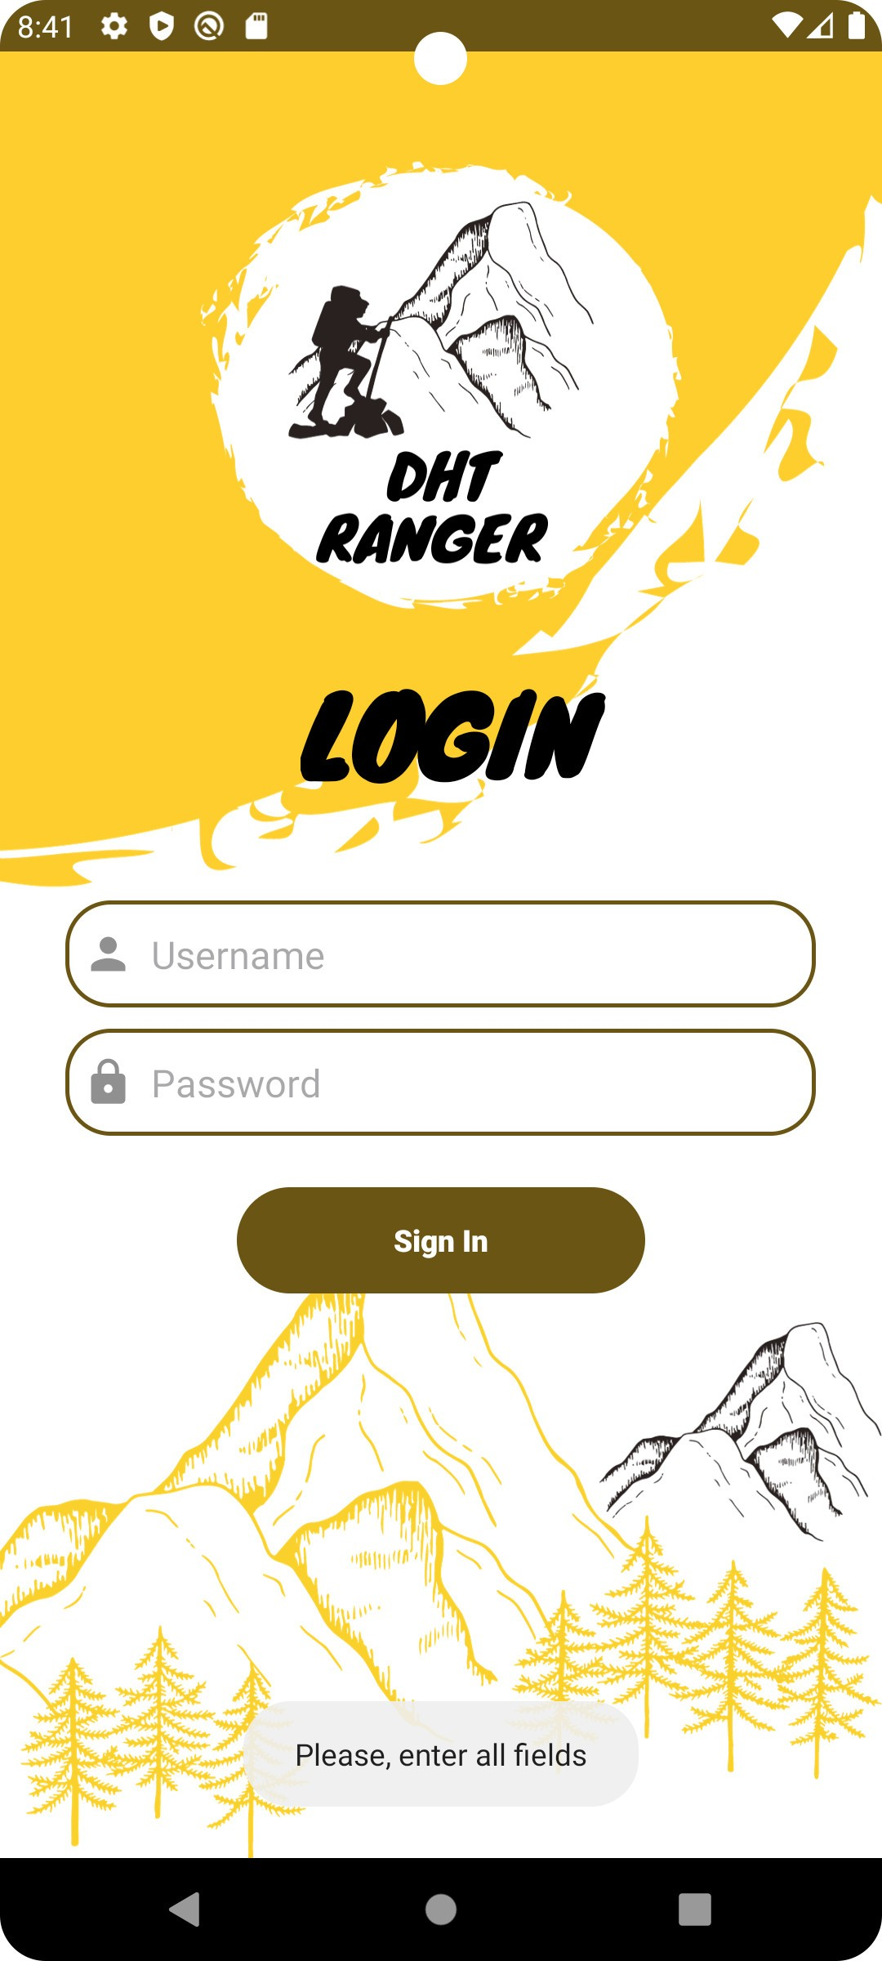

Figure 15. Login page

* **Explanation of the code of the login page:**

To refer to the button in the layout, a private Button variable called btnSignIn is declared. The overrides the onCreate method. Upon creating the activity, this method is invoked. setContentView(R.layout.activity_sign_in); sets the activity's content view to the layout specified in the activity_sign_in XML file. Using its ID (SignIn), locate the btnSignIn button in the layout to initialize it. Using its ID (SignIn), locate the btnSignIn button in the layout to initialize it. For the "Sign In" button (btnSignIn), a click listener is configured. An intent to launch the BottomActivity is created when the "Sign In" button is clicked. The change to the BottomActivity is started by the startActivity(intent).

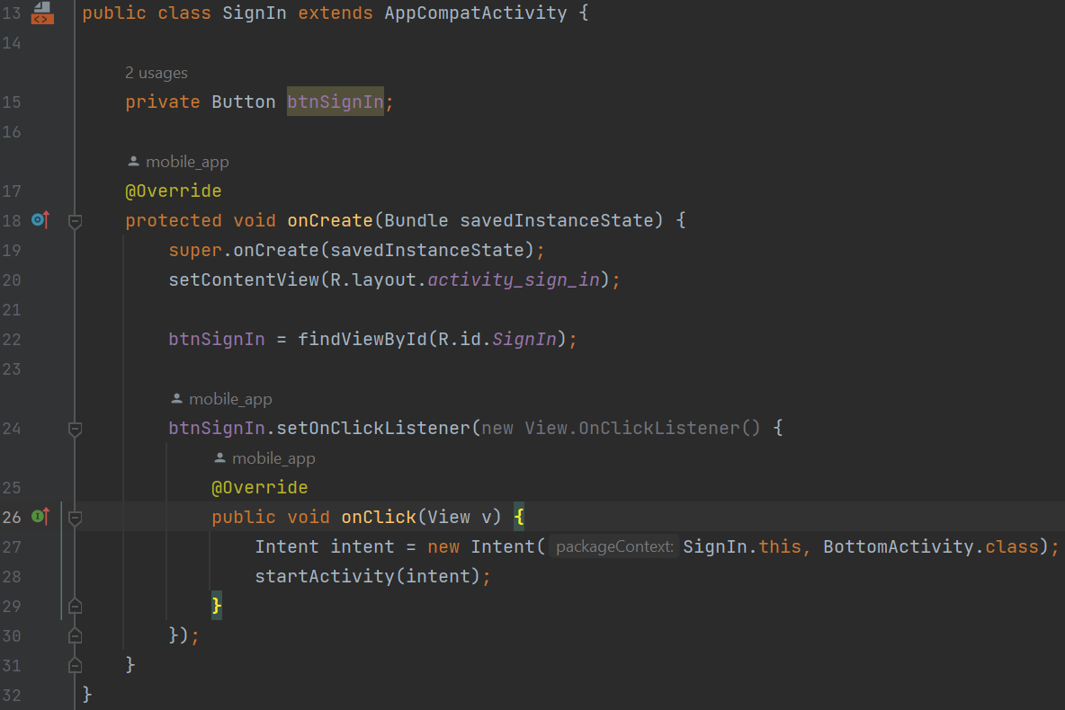

Figure 16. The code of the login page is line 13-32

* **Homepage:** Users will be able to view hike-related posts shared by other users on the homepage. Giving insights into the specifics and observations related to different hiking experiences of the other users.

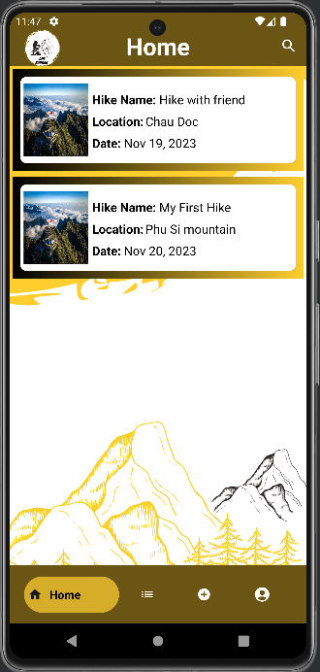

Figure 17. Homepage

* **Explanation of the code of the homepage:**

This is the onCreateView method, where different UI elements are initialized and the layout for the fragment is inflated.

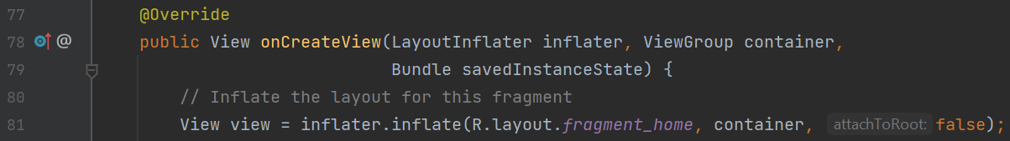

Figure 18. The code of the homepage is line 77-78

Frames, buttons, and RecyclerView are among the layout elements that are initialized.

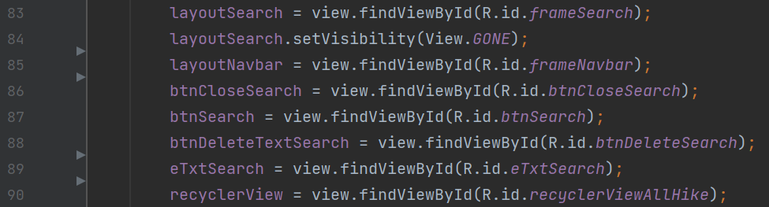

Figure 19. The code of the homepage is line 83-90

Database operations create an instance of SqlQuery. RecyclerView is connected to a HikeAdapter that has been configured using data obtained from selectAllHikes() function in SqlQuery class.



Figure 20. The code of the homepage is line 95-97

On the search input field (eTxtSearch), a TextWatcher is configured. It watches for text changes and modifies RecyclerView's filter accordingly. The navigation bar layout is hidden, and the search layout is visible when the search button (btnSearch) is clicked. The navigation bar layout is visible, and the search layout is hidden when the close search button (btnCloseSearch) is clicked.

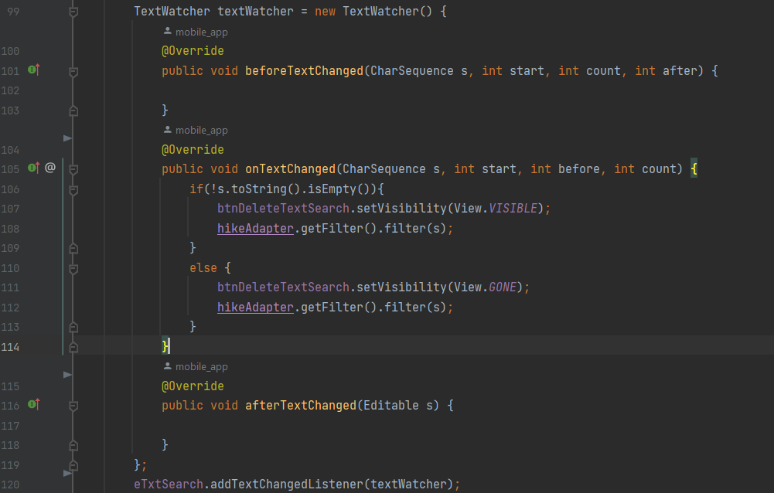

Figure 21. The code of the homepage is line 99-120

The navigation bar layout is hidden, and the search layout is visible when the search button (btnSearch) is clicked. The navigation bar layout is visible, and the search layout is hidden when the close search button (btnCloseSearch) is clicked. The search input text (eTxtSearch) is cleared when the delete text button (btnDeleteTextSearch) is clicked. Returning is the View that represents the fragment.

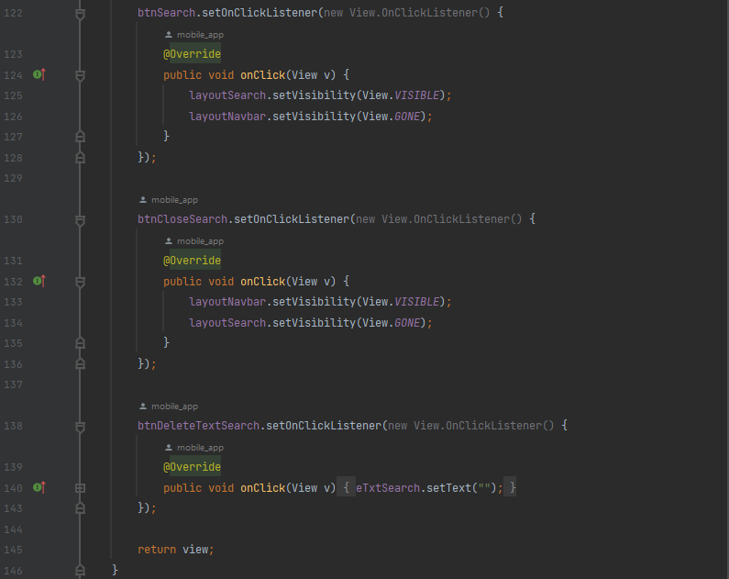

Figure 22. The code of the homepage is line 122-146

* **Add a new hike page:** Users enter information about a hike, including its name, location, parking, level, length, description, and optional photos, on the "Add New Hike" page. Upon selecting "confirm," a pop-up window asks users to confirm the information they entered. When the users click on confirm button to confirm their information of hike that they filled. The application will notify a message to users know they add a new hike successfully. Then they can navigate to the List Hikes page to view the new hike just added.

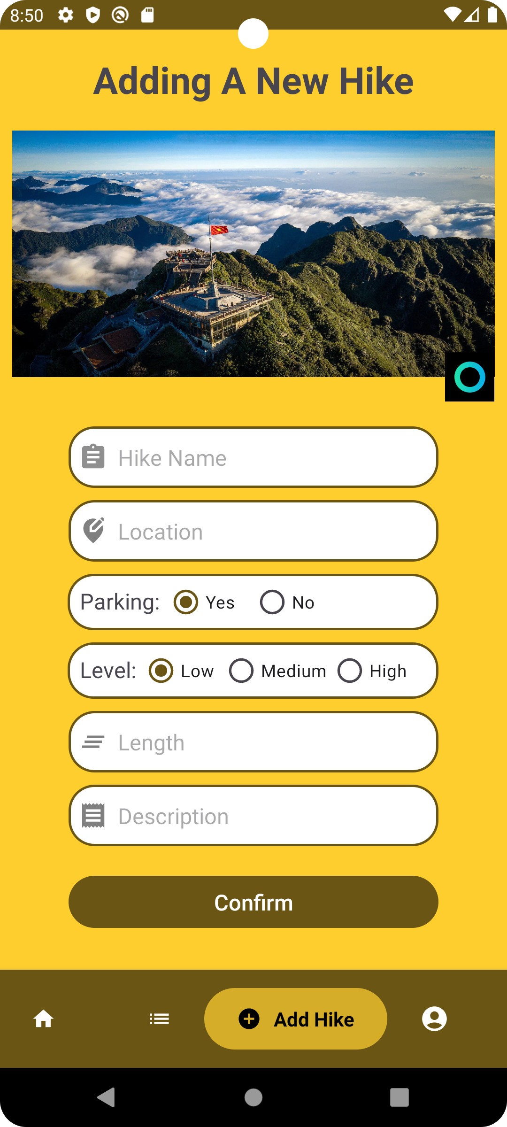 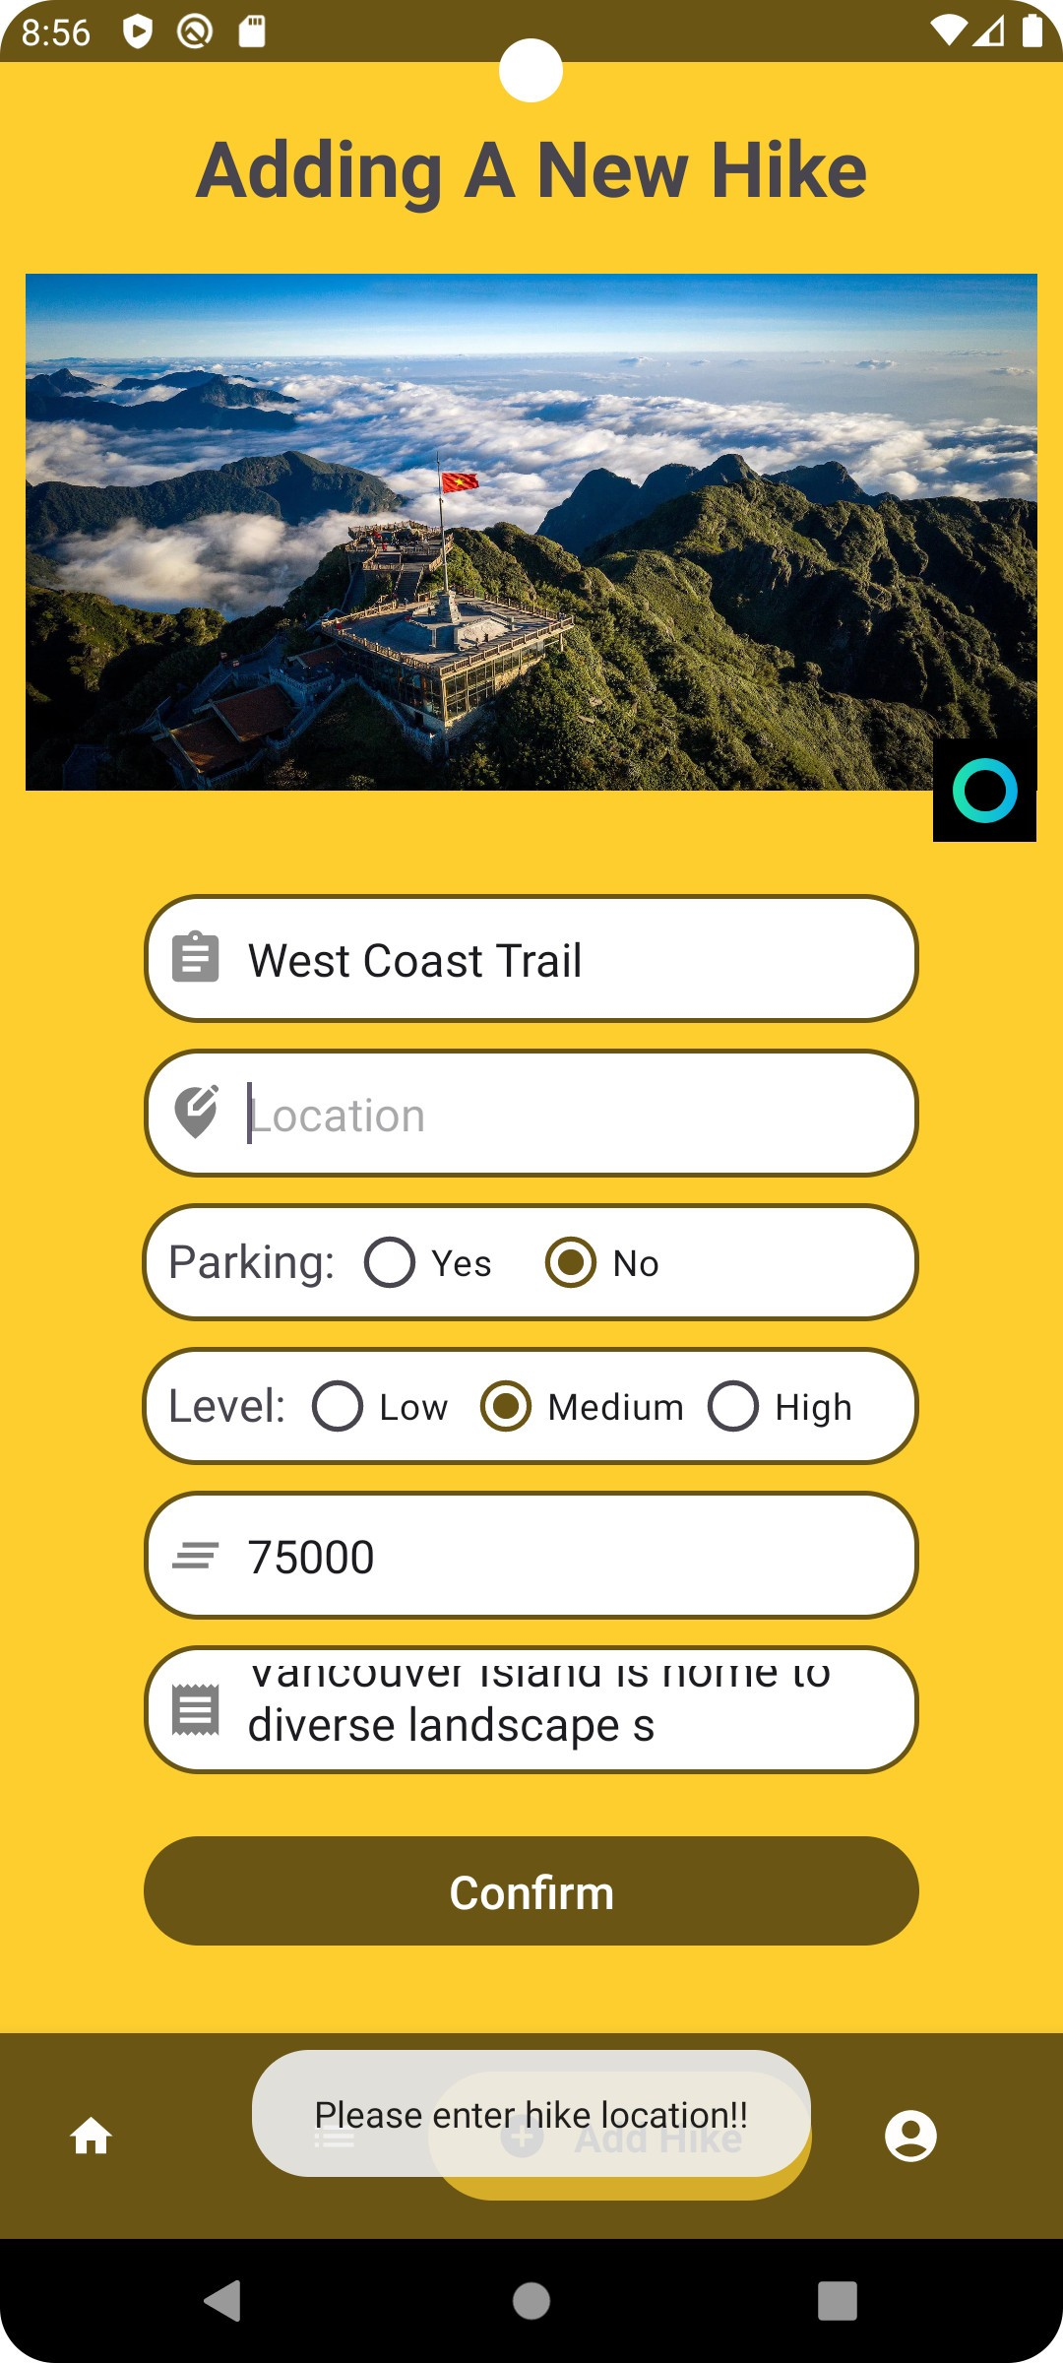 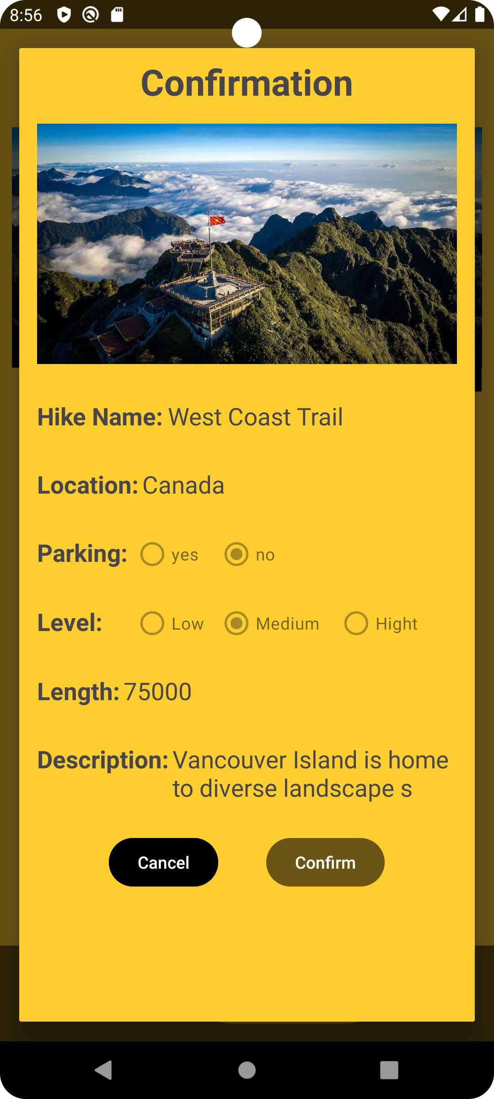

Figure 23. Add a new hike page

* **Explanation of the code of the add hike page:**

This is the onCreate method of the fragment. It retrieves arguments passed to the fragment, but in this case, it seems not to be used.

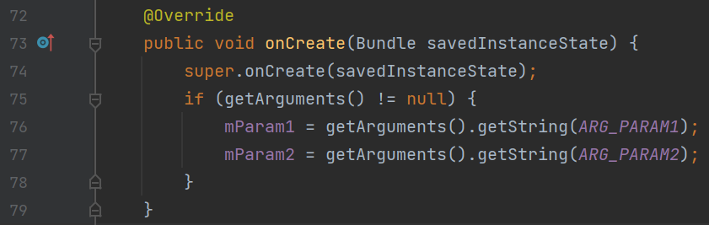

Figure 24. The code of the add hike page is line 72-79

This is the onCreateView method, where the layout for the fragment is inflated, and various UI elements are initialized.

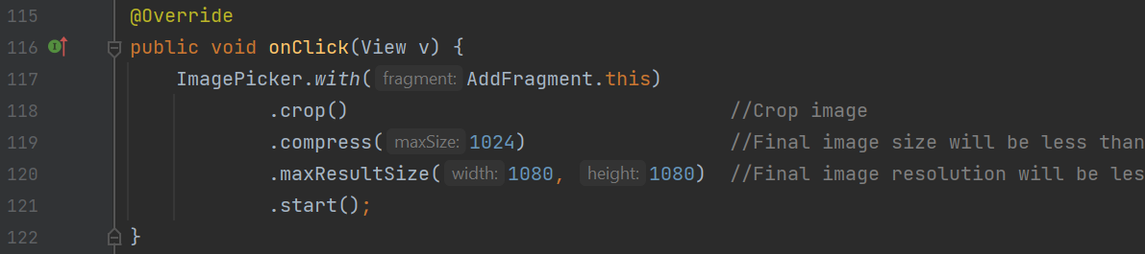

Figure 25. The code of the add hike page is line 115-122

This method is called when the user selects an image. It retrieves the selected image URL and display it.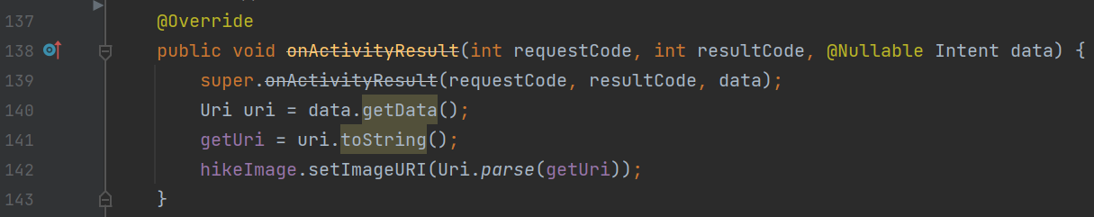

Figure 26. The code of the add hike page is line 137-143

This method validates the input information, showing a toast message if any field is missing or the data of field incorrectly.

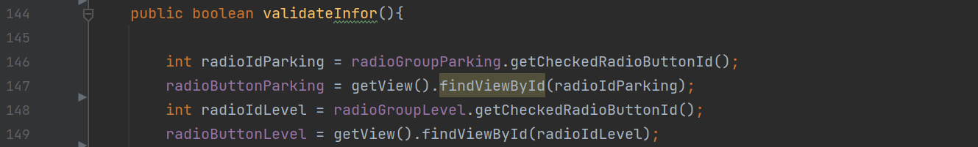

Figure 27. The code of the add hike page is line 144-149

This method generates and shows a dialog box (popup) with the data that the user entered for verification. The code in question manages the user interface (UI) and logic involved in creating a new hike. This includes handling image selection, validating input, and presenting a confirmation popup.

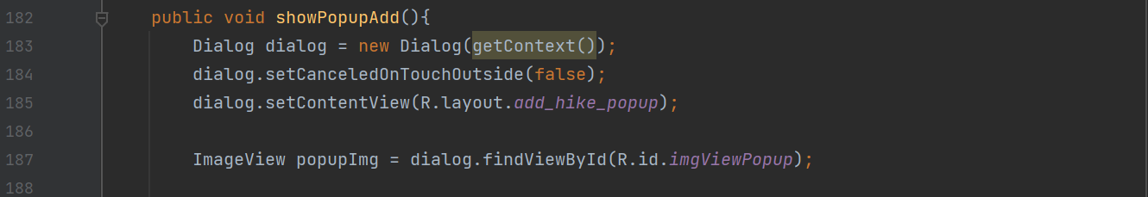

Figure 28. The code of the add hike page is line 182-188

* **List page:** Users can find extensive information about different hiking trails on the hiking page. Users can edit certain attributes within the detailed view page, such as the name, location, length, level, parking, and description information of the hike. Moreover, sharing information about the hike, starting its deletion, and adding observations are all possible with the detailed view.

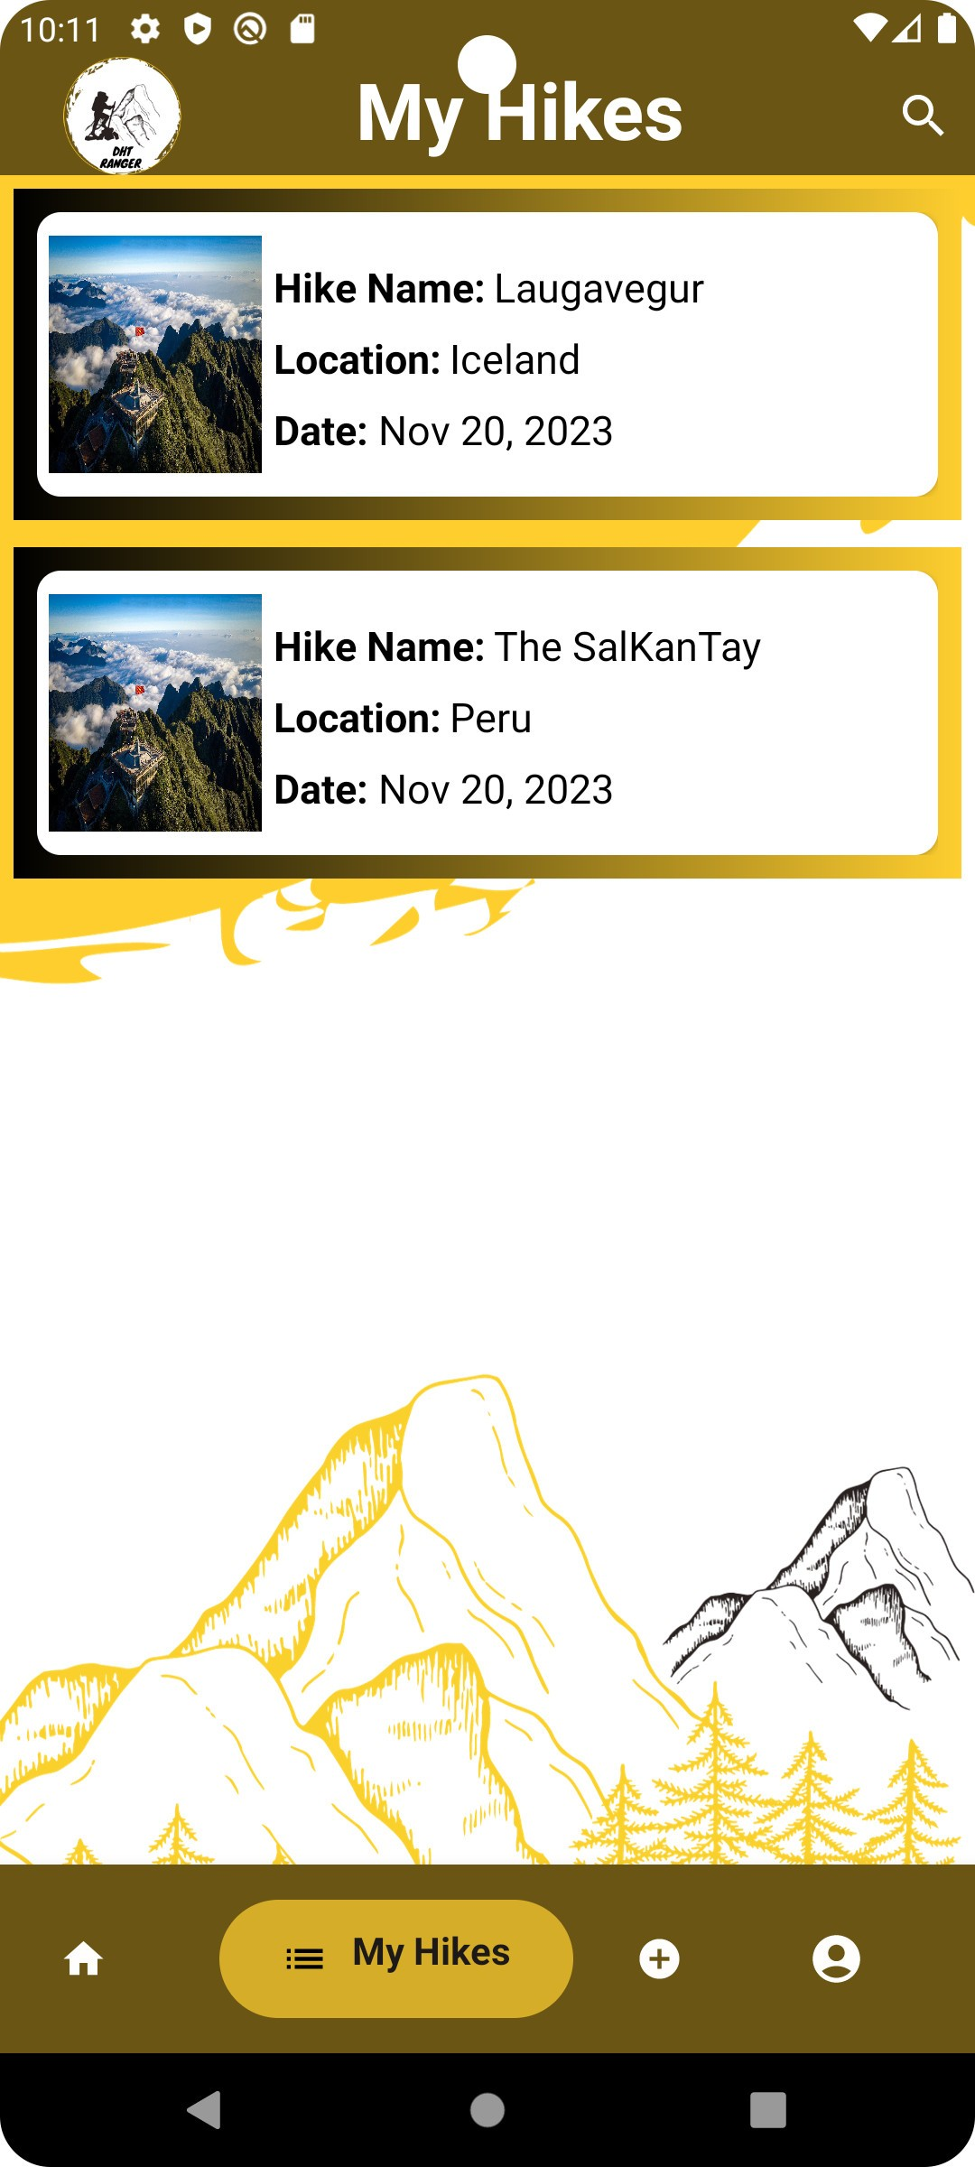 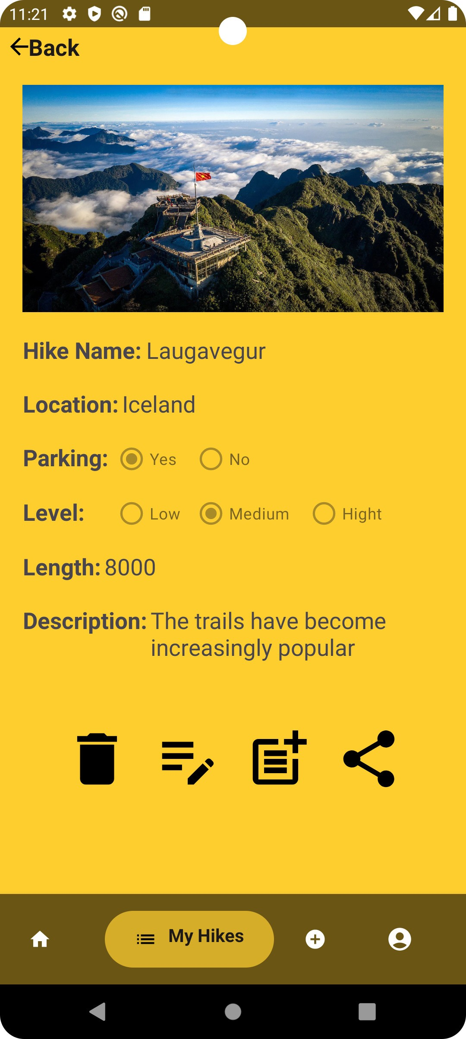

Figure 29. List hike page and view detail hike page

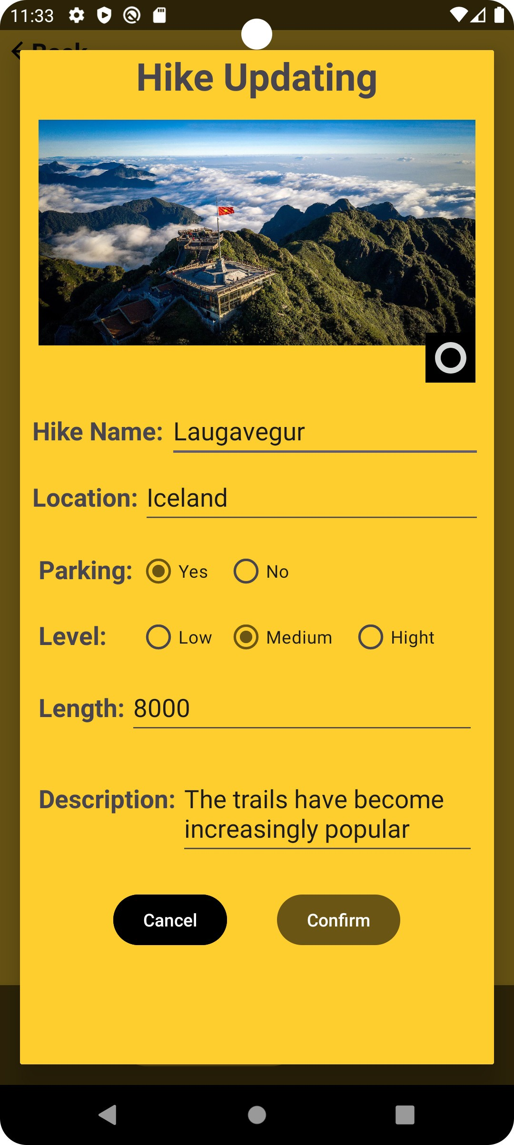 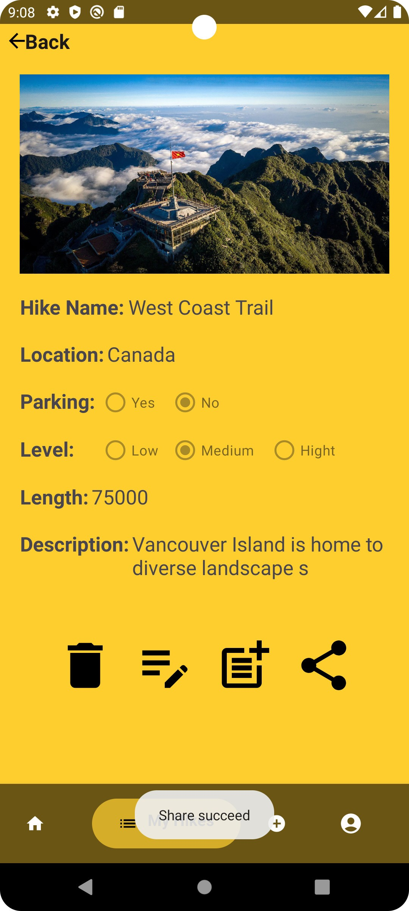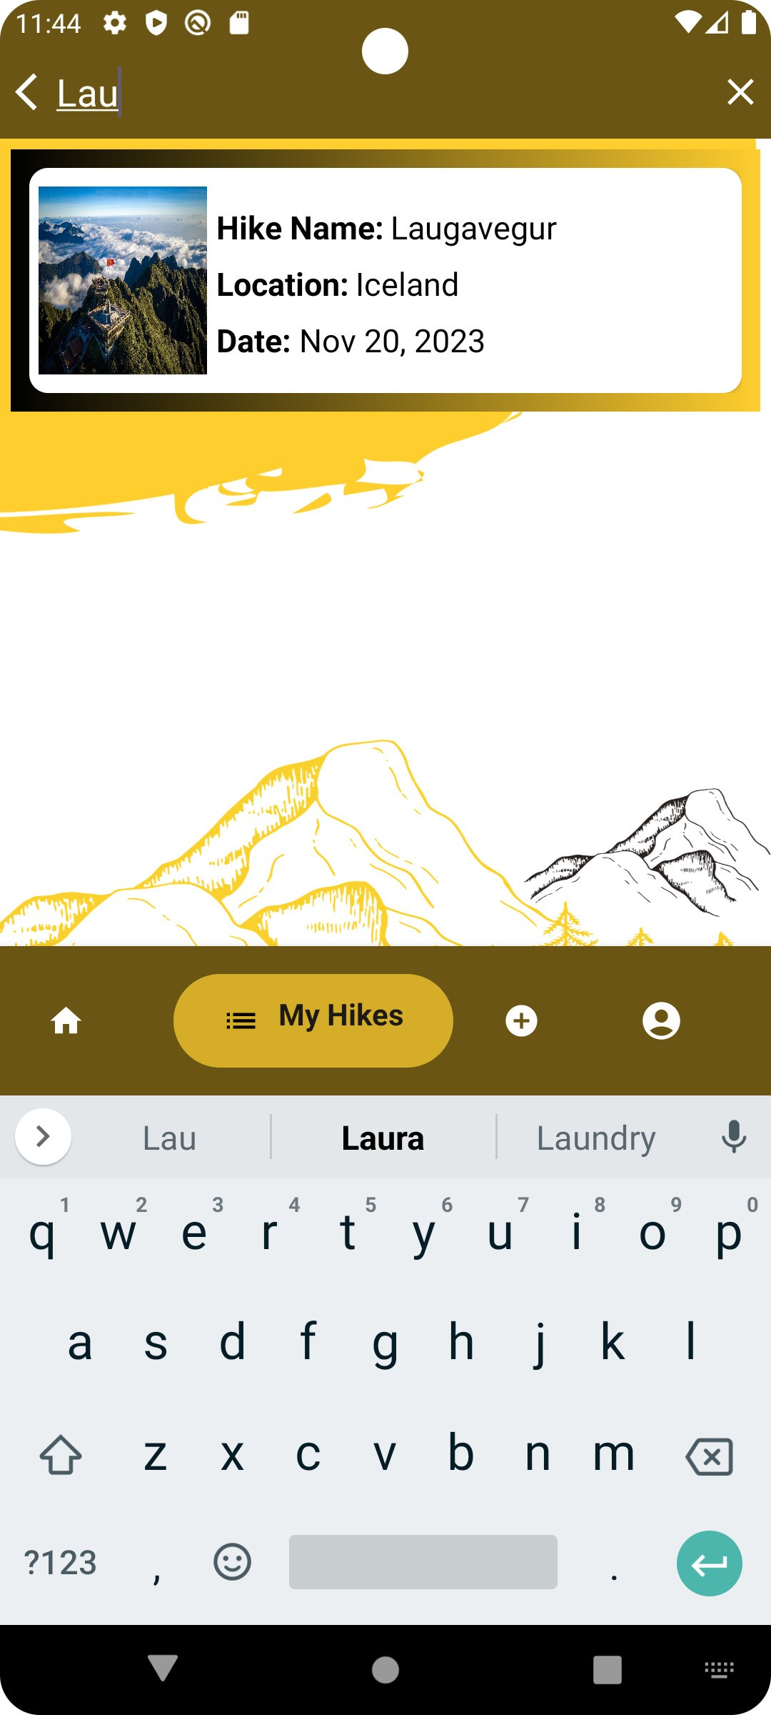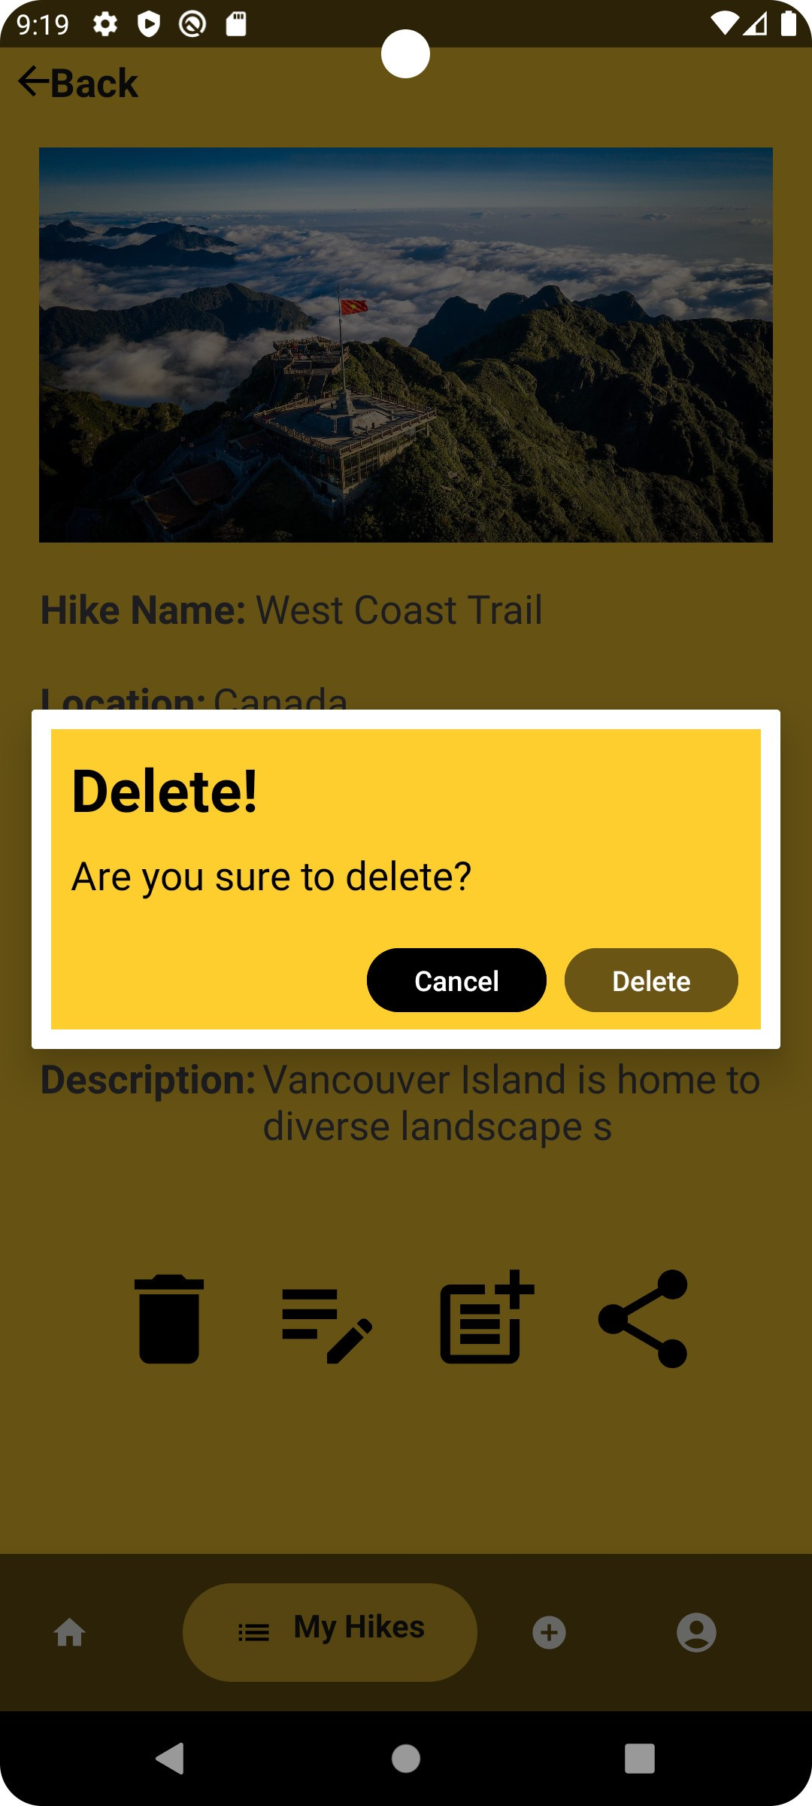

Figure 30. Edit function, share function, search function, and delete function

* **Explanation of the code of the list page:**

This is the onCreateView method, where the layout for the fragment is inflated, and various UI elements are initialized. Buttons, text views, radio buttons, and an image view are initialized.

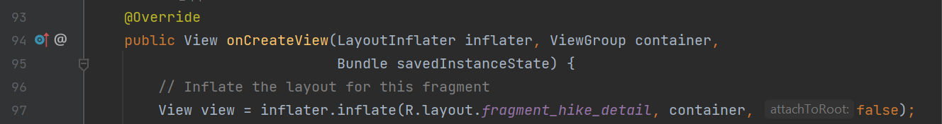

Figure 31. The code of the list page is line 93-97

Data is retrieved from the bundle, including information about the hike (ListHikes), the state, and the user ID.



Figure 32. The code of the list page is line124-127

If a valid hike object is received, populate the UI components with the details of the hike.

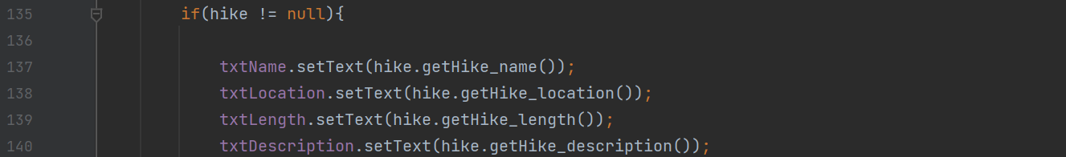

Figure 33. The code of the list page is line135-140

Methods for showing delete and edit popups are defined, handling user interactions within those popups and share feature in call.

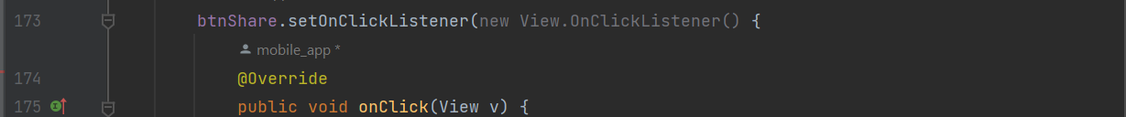

Figure 34. The code of the list page is line 173-175

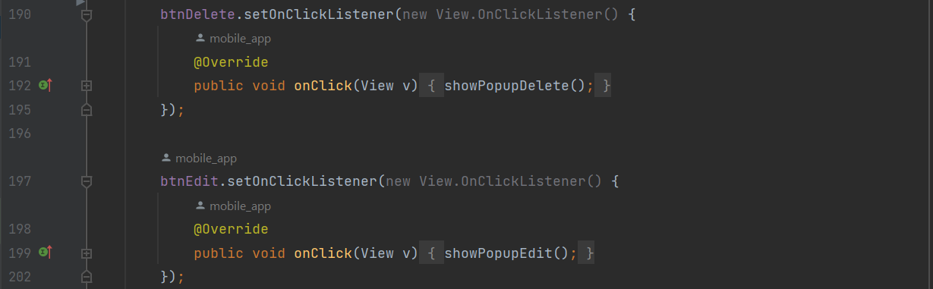

Figure 35. The code of the list page is line 190-202

An image picker is set up to allow the user to select or edit an image for the hike during the edit process.

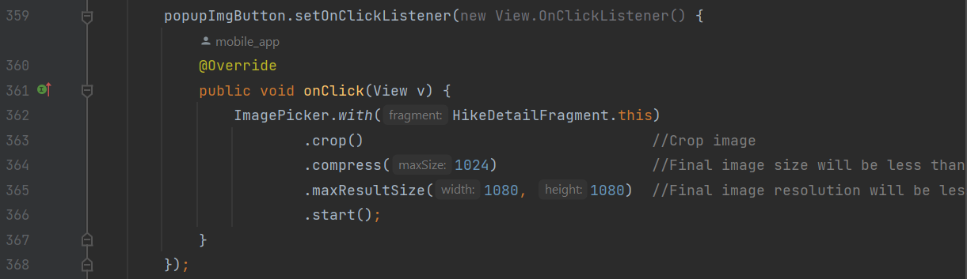

Figure 36. The code of the list page is line 359-368

This method handles the result of the image selection or editing.

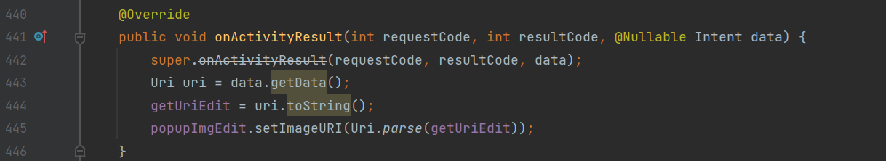

Figure 37. The code of the list page is line 440-446

A convenient method for displaying toast messages.

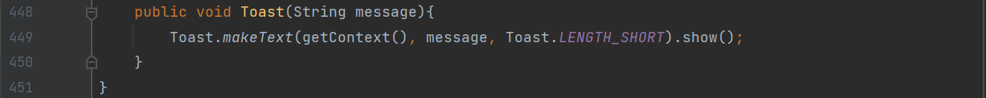

Figure 38. The code of the list page is line 448-451

* **Add a new observation page:** Name and description are among the attributes that users can enter on the observation addition page. An error message asking the user to reenter the information will appear if the input contains exceptions; if not, the addition will be successful.

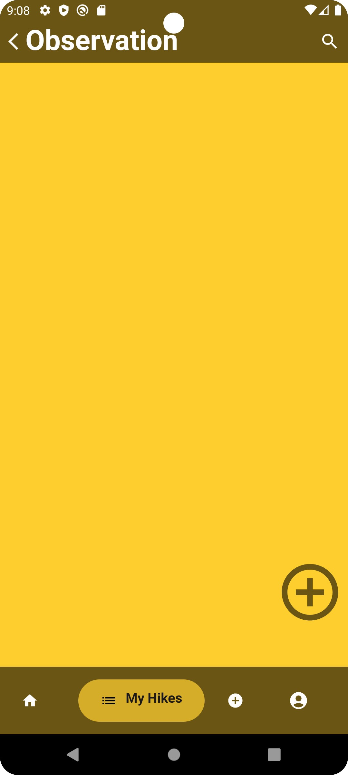 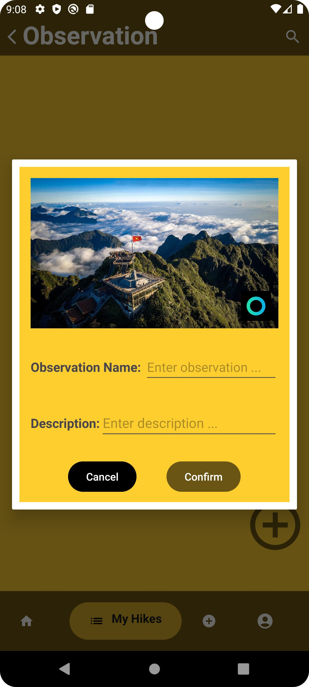 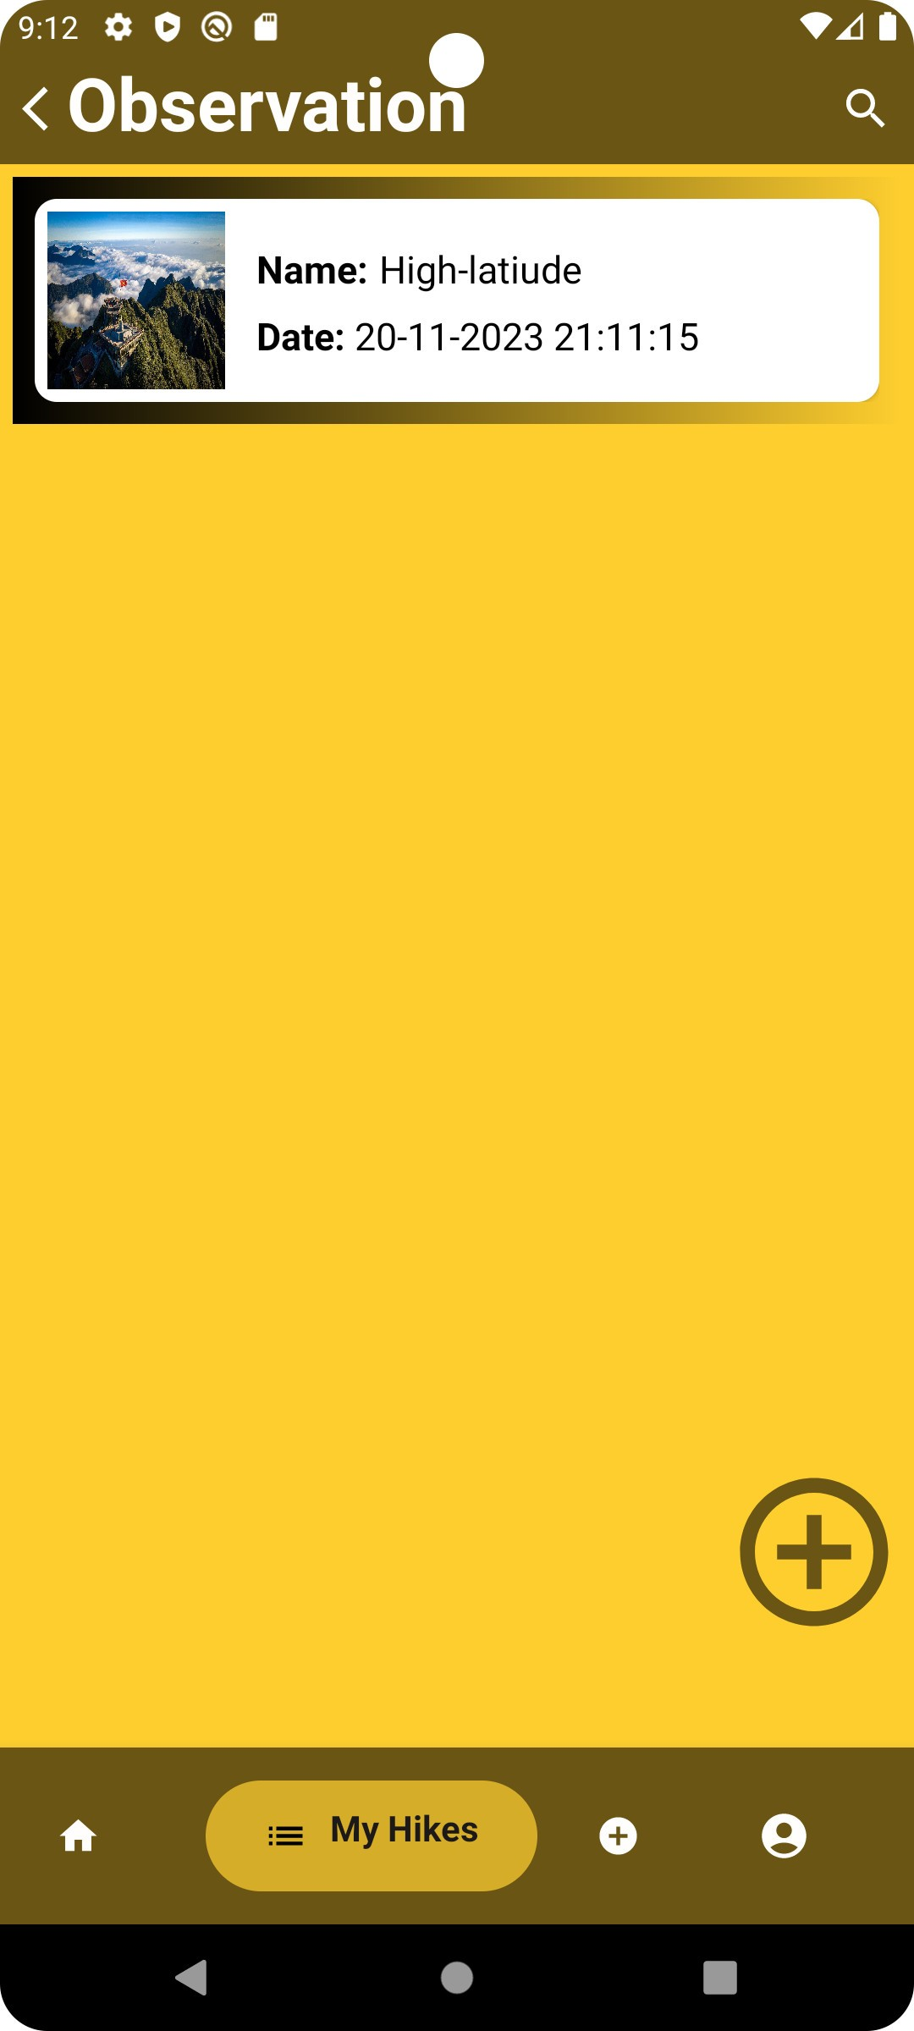

Figure 39. Add a new observation function

* **Explanation of the code of the add observation page:**

This method creates a new instance of the AddObservationFragment and sets arguments.

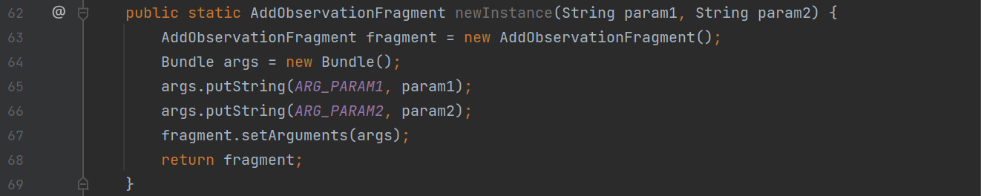

Figure 40. The code of the observation page is line 62-69

The arguments set during fragment creation are retrieved using this method.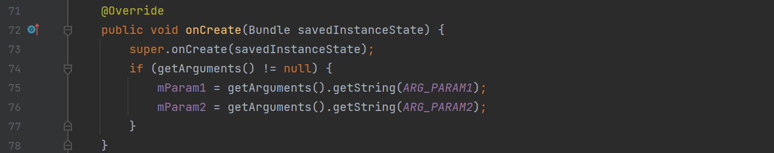



Figure 41. The code of the observation page is line 71-78

Initialization of a RecyclerView to display observations, buttons, and a search bar, among other UI elements.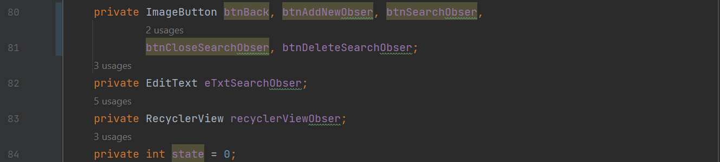

Figure 42. The code of the observation page is line 80-84

This method inflates the layout for the fragment, initializes UI components, and sets up event listeners.

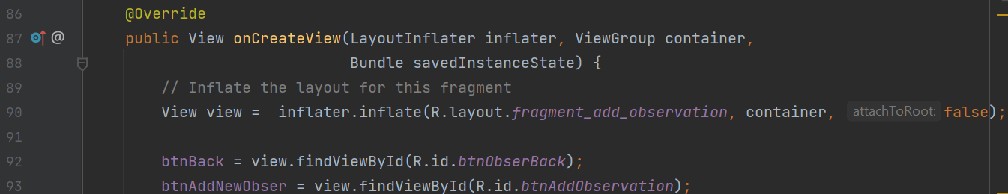

Figure 43. The code of the observation page is line 86-93

It creates an adapter for RecyclerView and retrieves observations from the database pertaining to a particular hike.

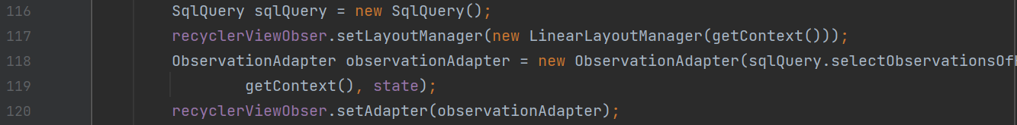

Figure 44. The code of the observation page is line 116-120

A TextWatcher is set on the search input field (eTxtSearchObser). It filters the observations based on the entered text.

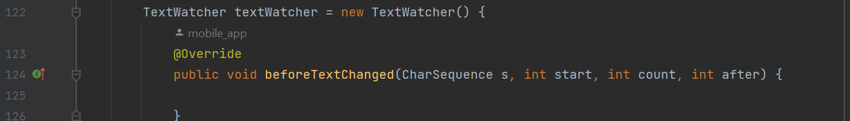

Figure 45. The code of the observation page is line 122-126

When the search button is pressed, it causes the navigation bar layout to become hidden and the search layout to become visible.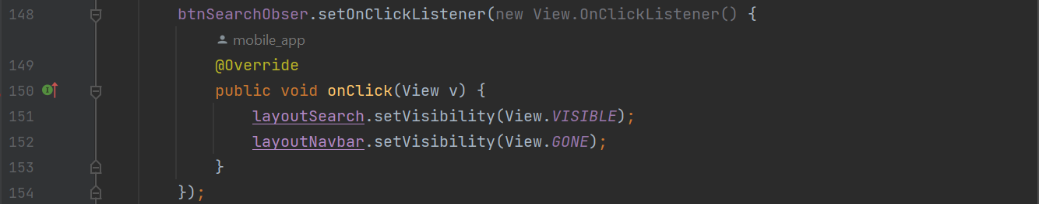

Figure 46. The code of the observation page is line 148-154

When the close search button is clicked, it hides the search layout and makes the navigation bar layout visible.

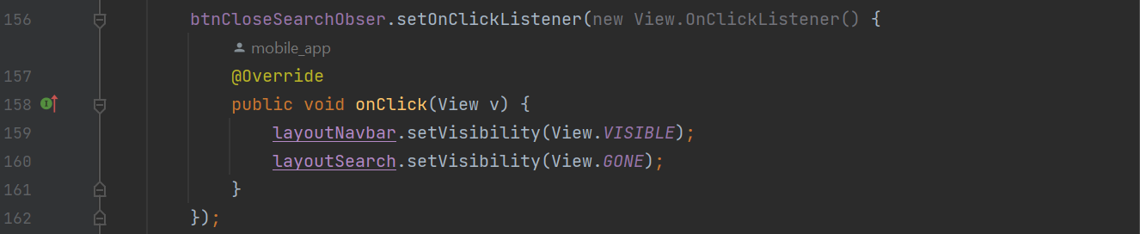

Figure 47. The code of the observation page is line 156-162

Clicking the delete text search button clears the text entered in the search field.

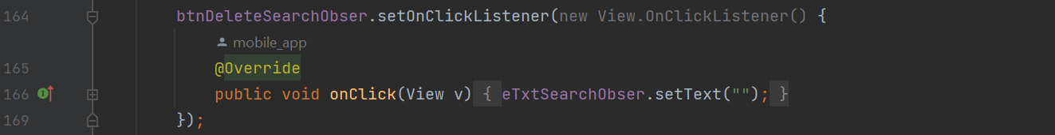

Figure 48. The code of the observation page is line 164-169

Clicking the back button causes the current fragment to be removed from the back stack.

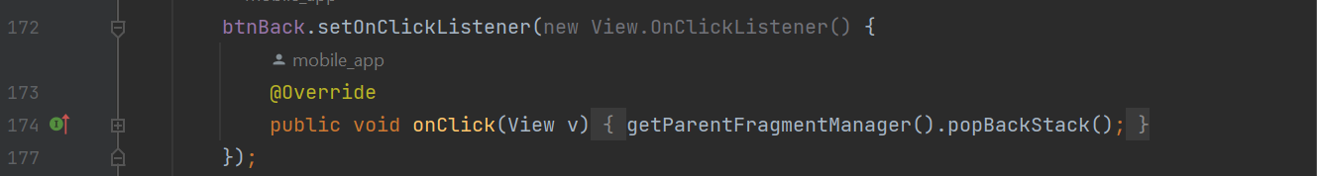

Figure 49. The code of the observation page is line 172-177

When the "add new observation" button is clicked, a popup window for adding a new observation appears.

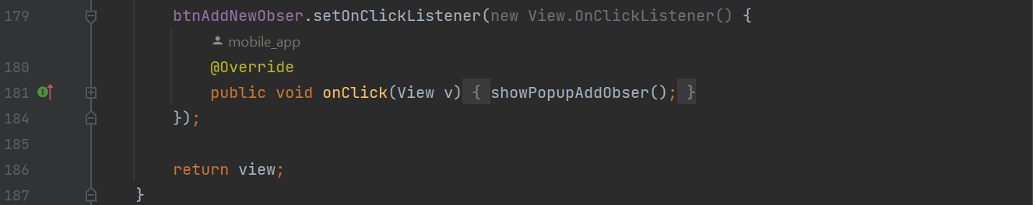

Figure 50. The code of the observation page is line 179-187

It displays a popup window with the ability to upload an image when making a new observation.



Figure 51. The code of the observation page is line 199-202

It deals with the image picker's output so that a new observation can be added.

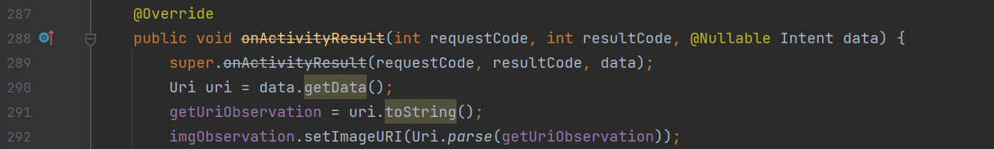

Figure 52. The code of the observation page is line 287-292

* **Function to edit and delete observations:** An observation's details can be accessed and reviewed by the user. The user can modify the observation's name and description while reviewing the details. Additionally, users can delete observations. Any attempt to edit when viewing an observation's detailed information without first entering valid information will result in an exception that will prompt the user to enter valid information before continuing with the editing. Moreover, users still have the option to delete observations.

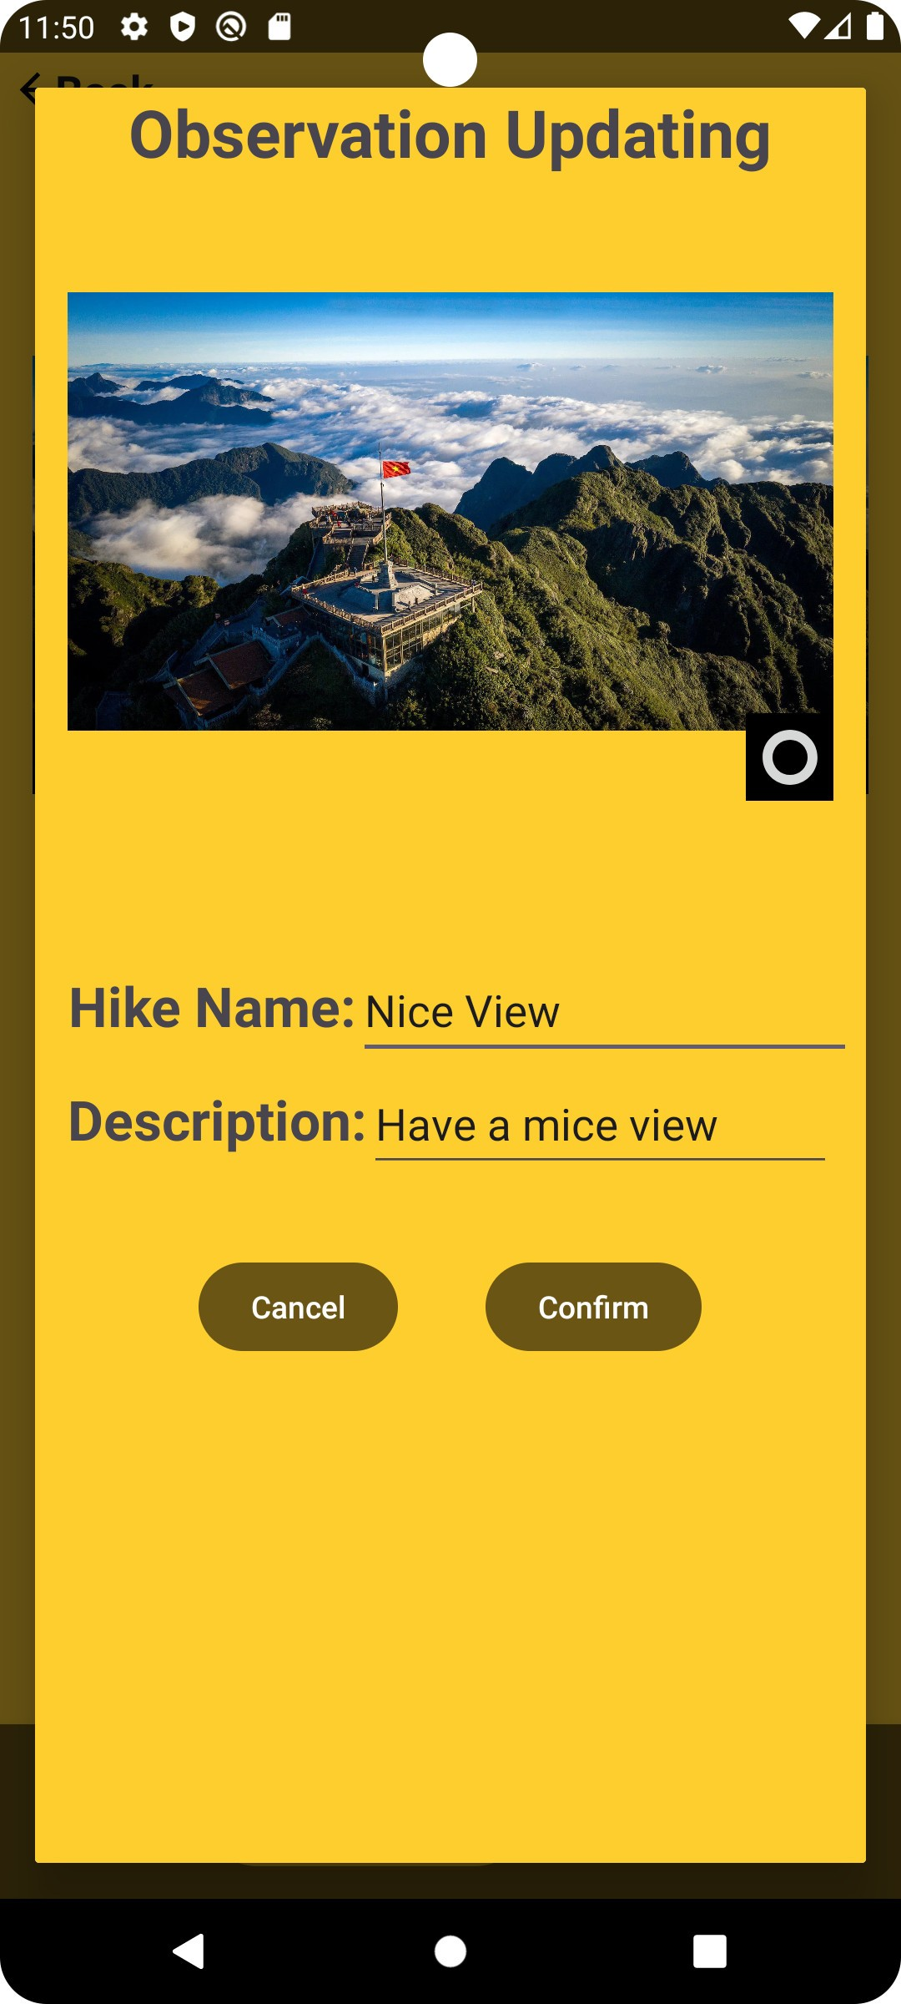 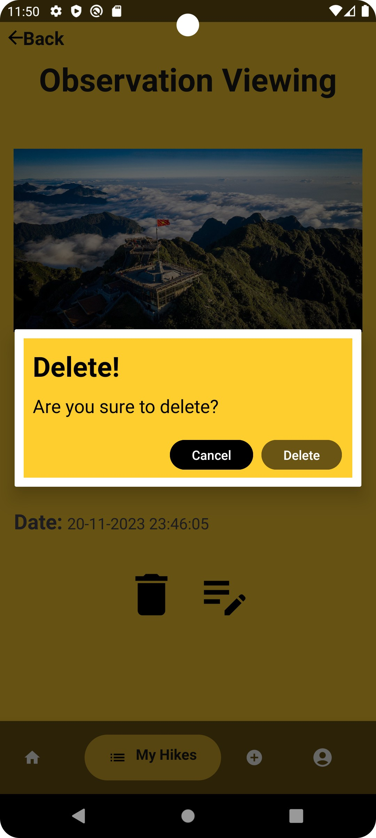

Figure 53. Update and delete observation function

* **Explanation of the code of the add observation page**:

This method creates a new instance of the ObservationDetailFragmentand sets arguments.

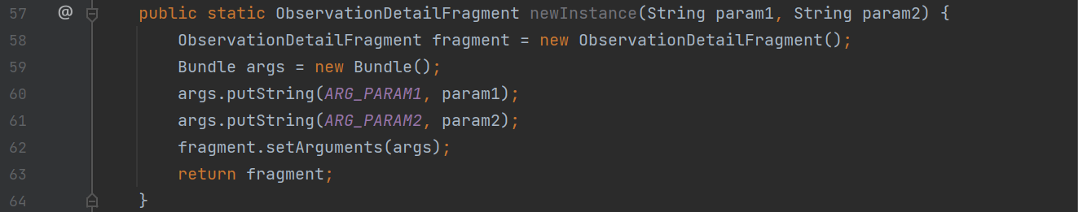

Figure 54. The code of the observation function is line 57-64

The arguments set during fragment creation are retrieved using this method.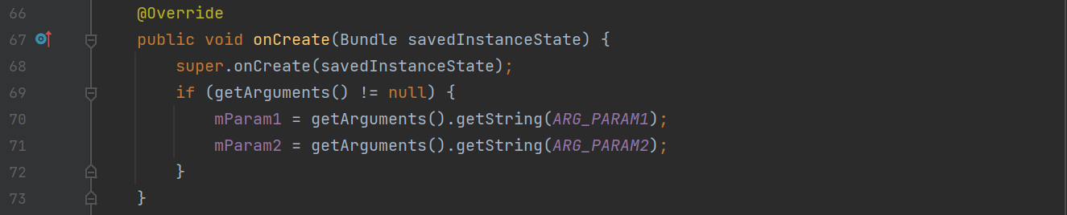

Figure 55. The code of the observation function is line 66-73

Initialization of different user interface elements, including image views, text views, and buttons.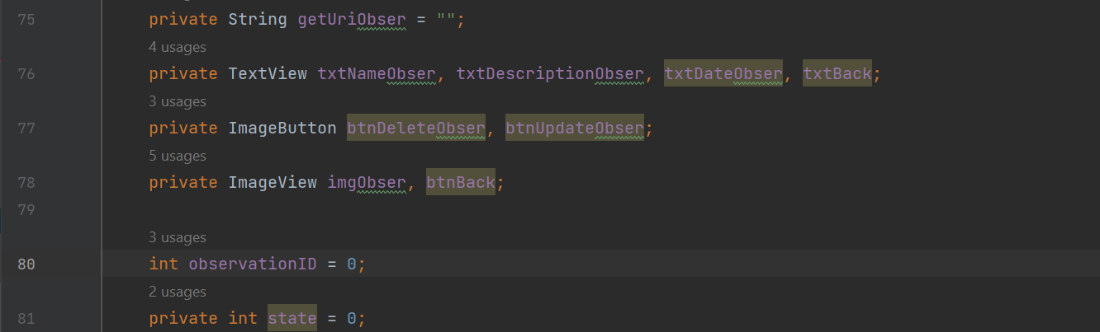

Figure 56. The code of the observation function is line 75-81

This function initializes UI elements, creates event listeners, and inflates the fragment's layout.

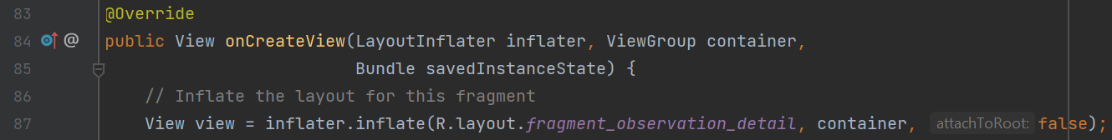

Figure 57. The code of the observation function is line 83-87

Extracts the state and specifics of the observation from the arguments.

Figure 58. The code of the observation function is line 89-91

Sets the text and image for the observation details.

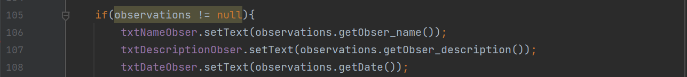

Figure 59. The code of the observation function is line 105-108

Manages button clicks for deleting, editing, and going back in time for observations.

 

Figure 60. The code of the observation function is line 126, 140, and 147

Displays a popup for editing observation details.

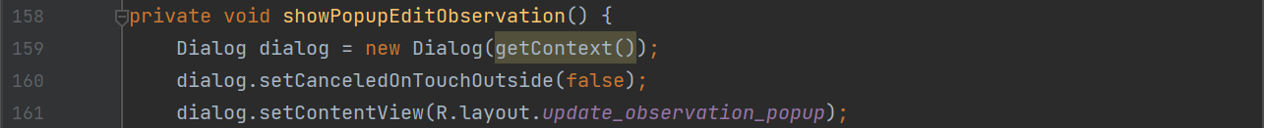

Figure 61. The code of the observation function is line 158-161

Displays a confirmation popup for deleting the observation.



Figure 62. The code of the observation function is line 237-240

Displays a toast message to notify users.



Figure 63. The code of the observation function is line 286-288

Handles the result of the image picker for updating the observation image.

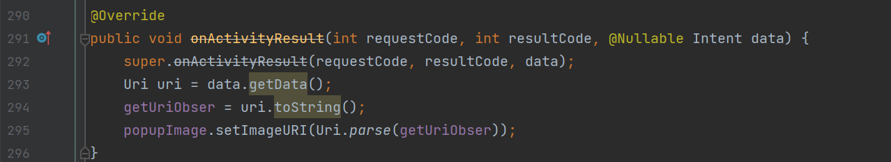

Figure 64. The code of the observation function is line 290-296

* **Profile page:** Users can view and manage all their information on the profile page. Users can make changes to their personal information in this section. If the user enters something incorrectly, exceptions will show up and they will need to be corrected.

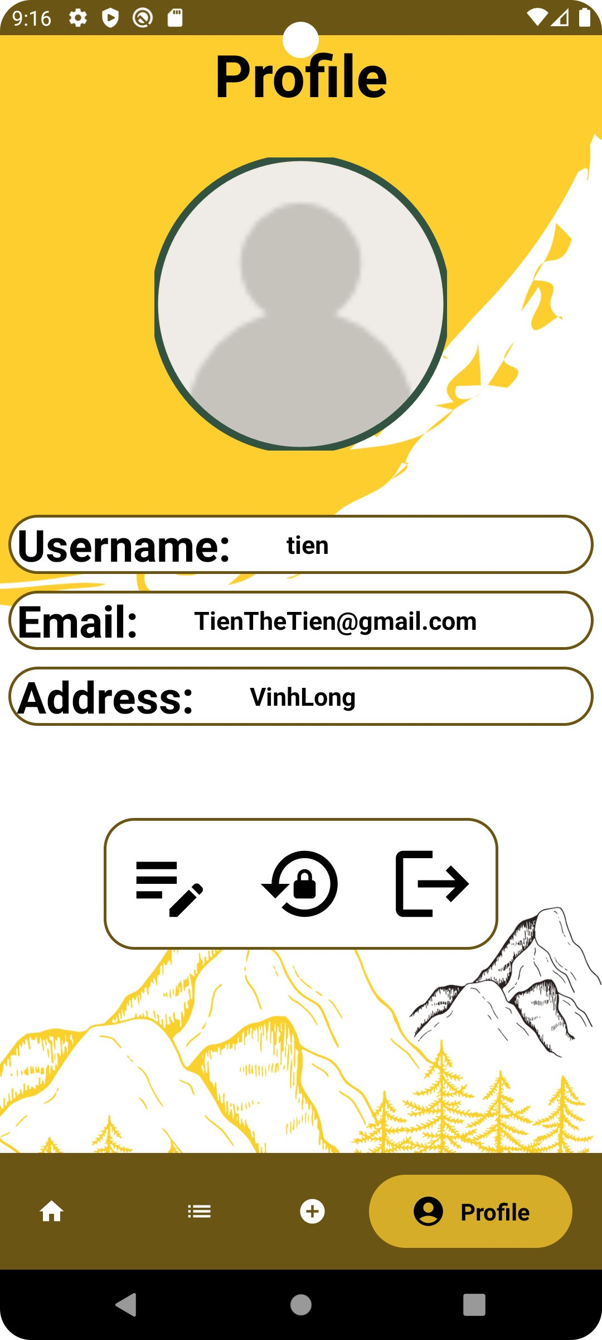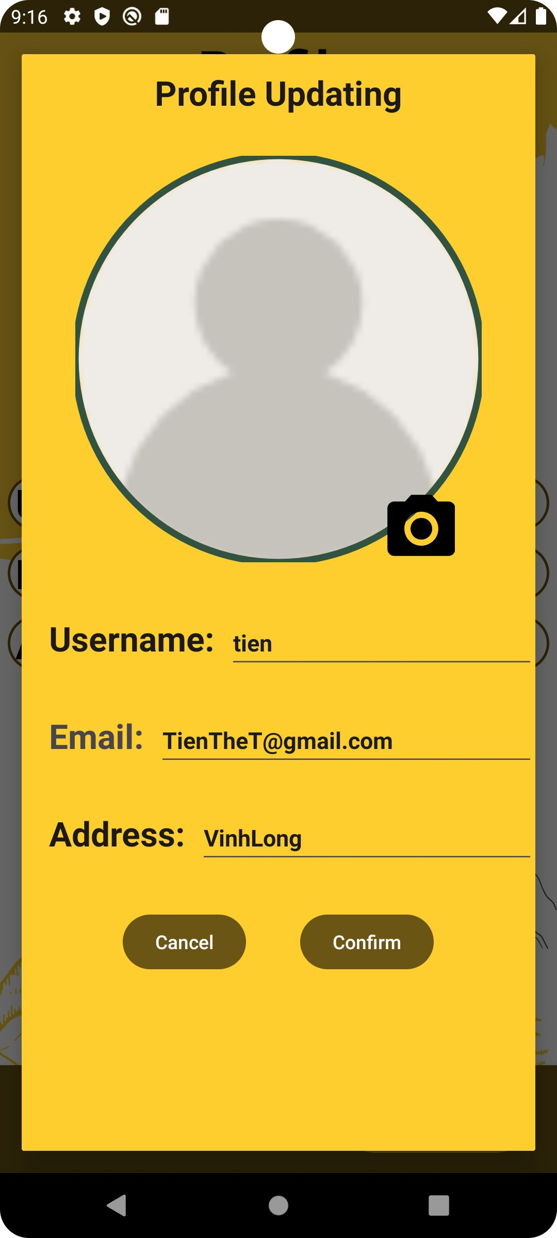

Figure 65. Profile page and edit profile function

By choosing the 'Change password' button, users can also modify their password. Users must input their current password into the system; if they enter it incorrectly, an exception notice will appear, prompting them to enter it again. Once authentication is successful, the user can enter a new password. In addition, the users must change password do not duplicate the old password before.

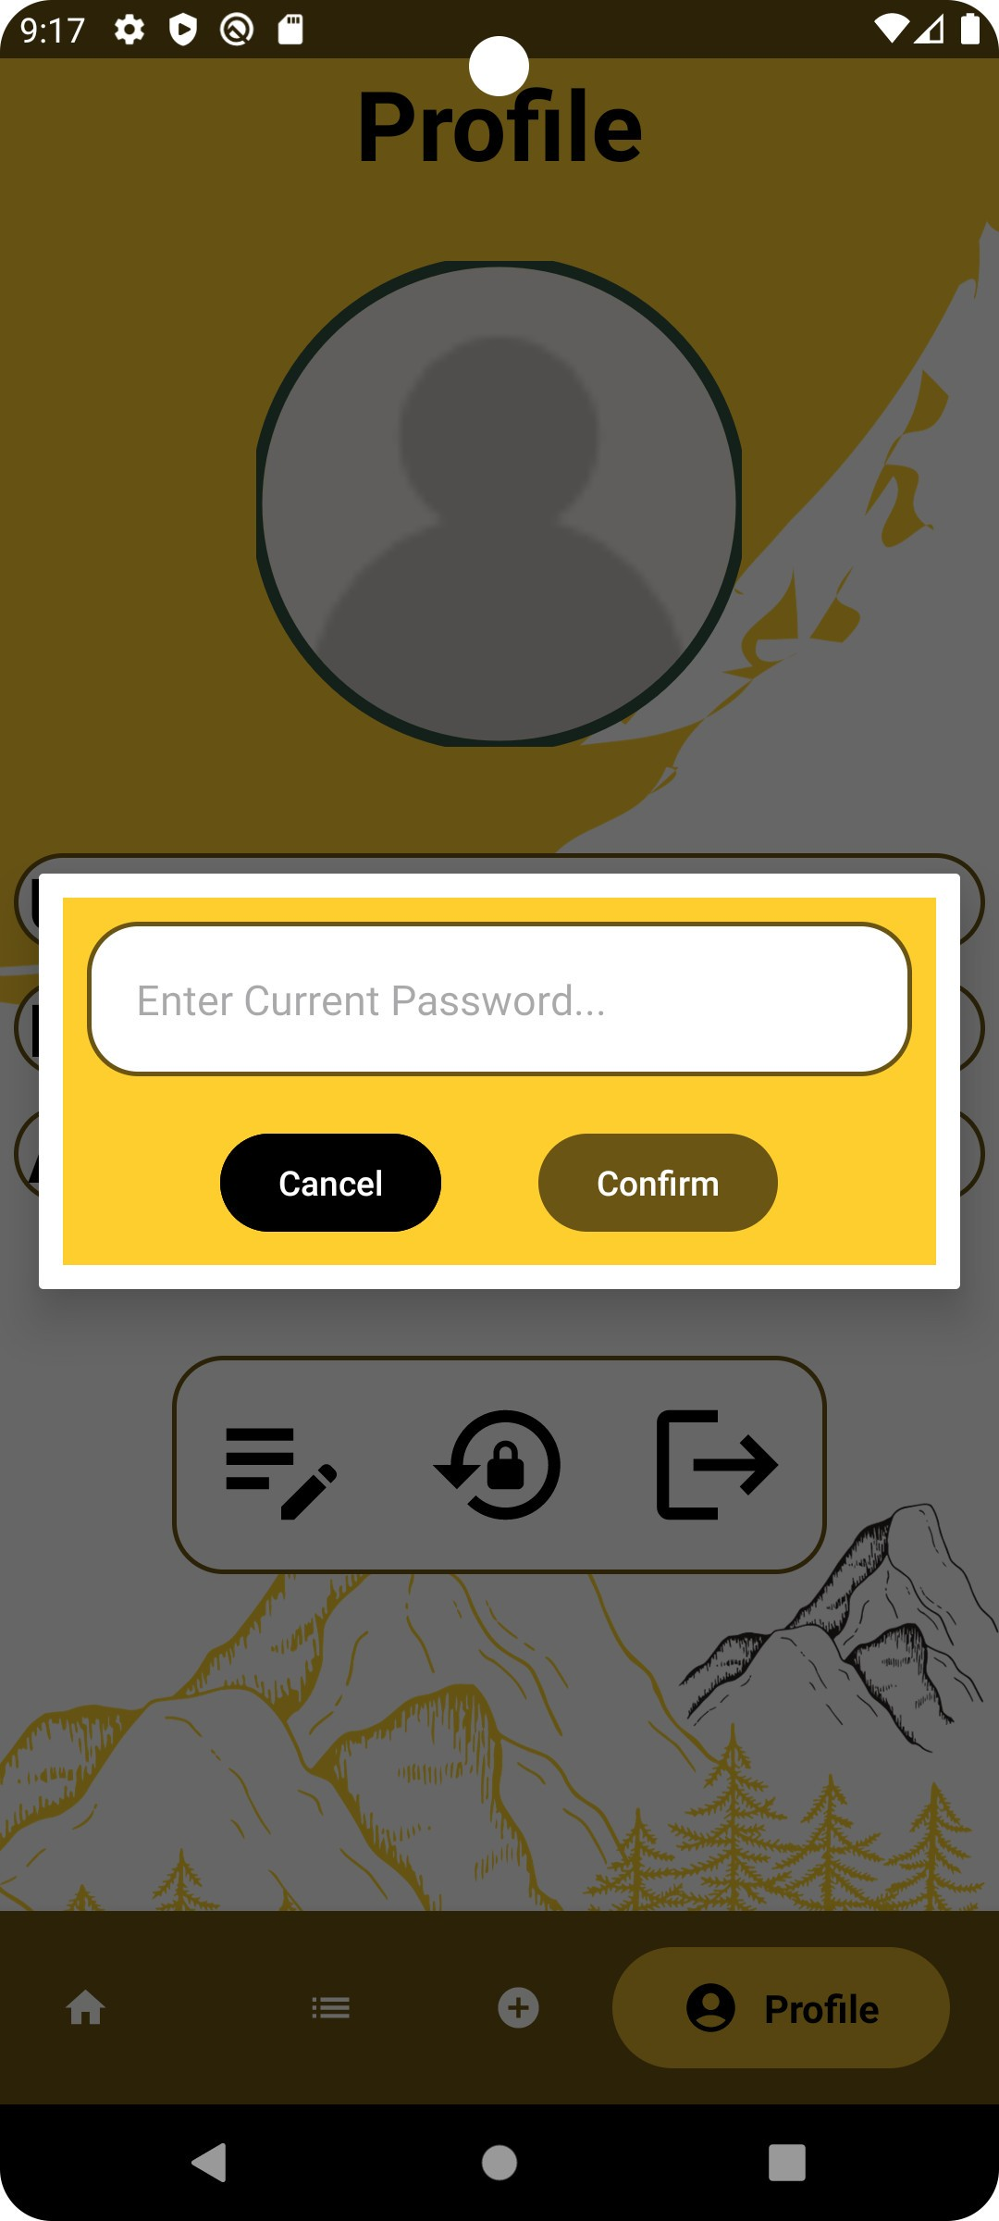 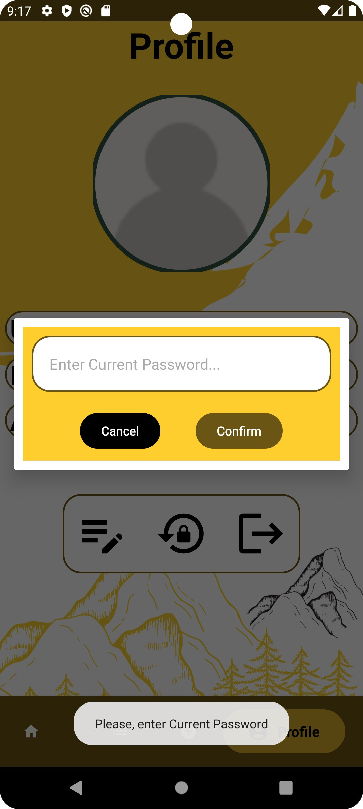 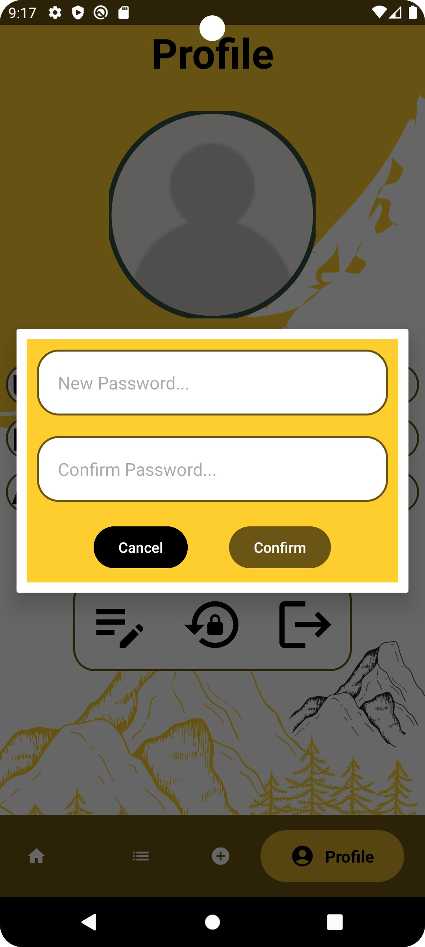

Figure 66. Change password function

* **Explanation of the code of the profile page:**

This method creates a new instance of the ProfileFragment and sets arguments.

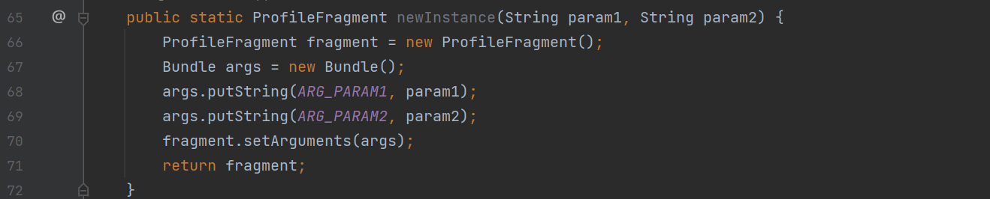

Figure 67. The code of the profile page is line 65-72

This method retrieves arguments set during fragment creation.

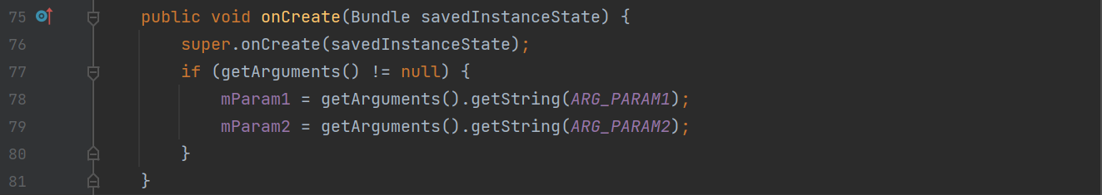

Figure 68. The code of the profile page is line 75-81

Initialization of the various user interface elements, including the text view, image view, buttons, and variables.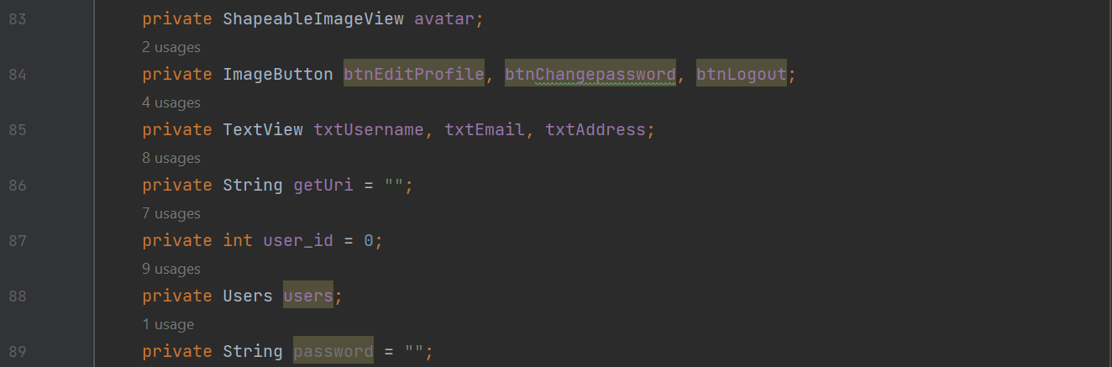

Figure 69. The code of the profile page is line 83-89

This function initializes UI elements, creates event listeners, and inflates the fragment's layout.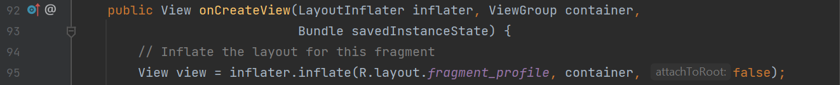

Figure 70. The code of the profile page is line 92-95

Retrieves user details from the arguments and sets them to UI components.



Figure 71. The code of the profile page is line 97-98

Handles button clicks for editing the profile, changing the password, and logging out.



Figure 72. The code of the profile page is line 106-108

Displays a popup for changing the user's password.



Figure 73. The code of the profile page is line 150-153

Displays a popup for creating a new password.



Figure 74. The code of the profile page is line 204-207

Displays a popup for editing user profile details.



Figure 75. The code of the profile page is line 282-285

Validates the updated profile information, checking for duplicate usernames and emails.



Figure 76. The code of the profile page is line 367-370

Handles the result of the image picker for updating the user's avatar.

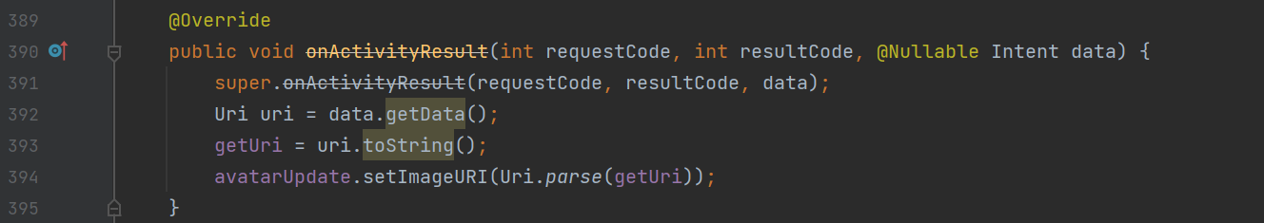

Figure 77. The code of the profile page is line 389-395

Displays a toast message.



Figure 78. The code of the profile page is line 397-400

**The video link:** <https://www.youtube.com/watch?v=aTrwXh9XdSk>

1. **Evaluate the application**

With its many useful features, the "DHT Ranger" app proved to be a useful tool for mountain enthusiasts. The goal of the user interface is to provide a positive user experience by being friendly and easy to navigate. Password hashing improves the security of customer information by guaranteeing the privacy and security of important data.

The software stands out due to its enormous storage capacity, which enables users to organize and store a lot of data about routes, equipment, and mountain regions. The features' creative and approachable design, which enables quick access to and usage of the app's services by users, is another asset. Nevertheless, a significant drawback is that "DHT Ranger" is only compatible with the Android operating system, which limits its usability for users of other platforms.

In the future, we will be expanding the software's compatibility to other platforms, such as iOS, to fortify it going forward, broadening its appeal and attracting a more varied user base. Furthermore, it is essential to make ongoing modifications to the functionality and design of the "DHT Ranger" in response to user feedback to maintain and improve the application’s quality.

1. **Conclusion**

Using Android Studio, we have created the "DHT Ranger" application, which primarily aims to provide mountain climbers with an all-inclusive record-keeping system. The application has reached significant milestones, enabling users to manage, view, and remove hike data, add observations made while traveling, and make use of effective search functions. After performing the DHT Ranger application, we learned a lot of lessons when performing this project and it will be new premise and steps in our future approach to software development. Looking ahead, it will be necessary to explore and expand cross-platform compatibility, enhance persistence mechanisms, and add new features to improve both the current app and future projects. The creation of "DHT Ranger" is both a stand-alone accomplishment and the first step in a process of learning and developing. Future advancements and innovations will be fueled by the learned insights. Our commitment to providing climbers with the best possible user experience through technological innovation is emphasized by our continuous improvement commitment. This dedication will always be the focus of our future work in the ever-changing field of software development.

# References

developer, a., 2023. *developer.android.com.* [Online]   
Available at: https://developer.android.com/  
[Accessed 20 11 2023].

DiMarzio, J., 2016. *Beginning Android Programming with Android Studio (Wrox Beginning Guides).* 4th ed. s.l.:Wrox.

James Gosling, B. J. G. L. S. J. G. B., 2005. *The Java Language Specification, Third Edition.* 3rd ed. s.l.:Addison Wesley.

Mikael Wiberg, C. W., 2018. International Journal of Mobile Human Computer Interaction (IJMHCI). *Digital Integration in the 3rd Wave of Mobile HCI: A Key Challenge for Overcoming the Inverted Digital Divide,* 10(2), p. 8.

Norman, D., 2002. *The Design of Everyday Things.* 1st ed. New York: Basic Books.

Paweł Weichbroth, Ł. Ł., 2020. Mobile Security: Threats and Best Practices. *Mobile Information Systems,* Volume 2020, p. 15.

SHNEIDERMAN, 2009. Designing the User Interface: Strategies for Effective Human-Computer Interaction, Global Edition. *Information Design Journal,* 17(2), pp. 157-158.

Smyth, N., 2018. *Android Studio 3.2 Development Essentials.* 9th ed. s.l.:Kotlin.

Ward, B., 2019. *SQL Server 2019 Revealed: Including Big Data Clusters and Machine Learning..* 1st ed. Germany: Apress.

Yvonne Rogers, H. S. J. P., 2015. *Interaction Design: Beyond Human-Computer Interaction.* 6th ed. s.l.:John Wiley & Sons Ltd .

# Appending A - Steps to perform adding environment variables to run the application

To use SQL Server to store, we will show you the way to connect and use SQL Server in our project.

First, we download the jtds-1.3.1-dist.zip library, then we will extract it.





Figure 79. JTDS library

After extracting open it and copy jtds-1.3.1.jar file.

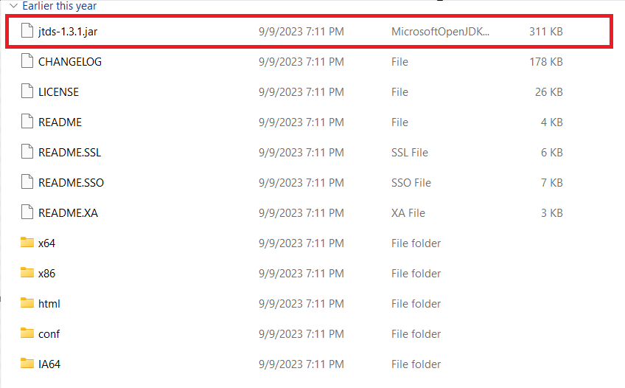

Figure 80. Copy JTDS file

Next, we open the project and access the libs folder of the project and paste the jtds-1.3.1.jar file just copy into them.

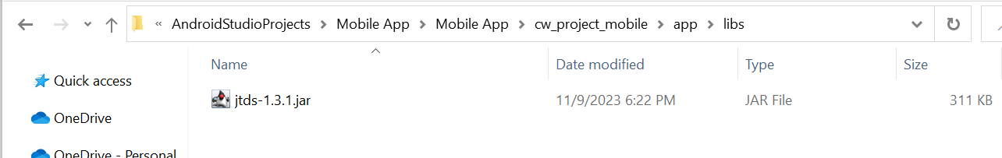

Figure 81. Paste the JTDS library to project

Then, we will copy the name of jtds-1.3.1.jar file and paste it to the path like this:



Figure 82. Path of libs in project

and copy all the path: D:\Learning\TopUp\Mobile (COMP1786)\cw_project_mobile\app\libs\jtds-1.3.1.jar. Then we will open the project in Android Studio and perform the some of following step to add this library:

step 1: Open the project and access the path below

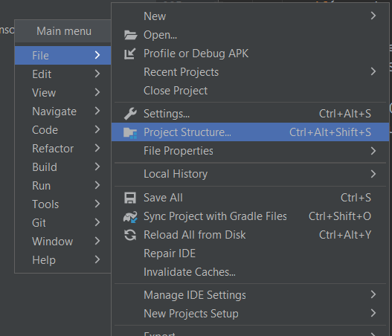

Figure 83. Performing apply the JTDS

Step 2: Perform apply the JTDS library

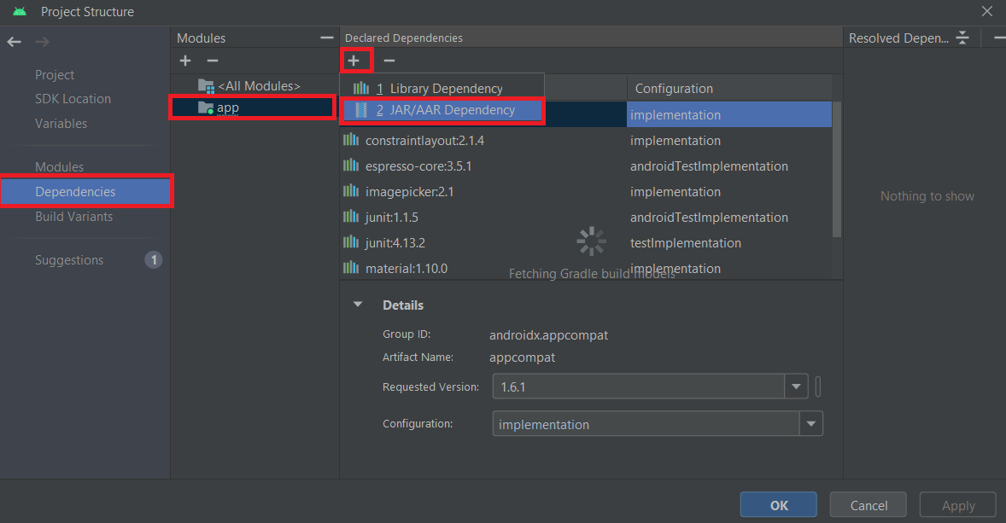

Figure 84. Performing apply the JTDS

Step 3: Paste the previously copied path and click OK, then click Apply.

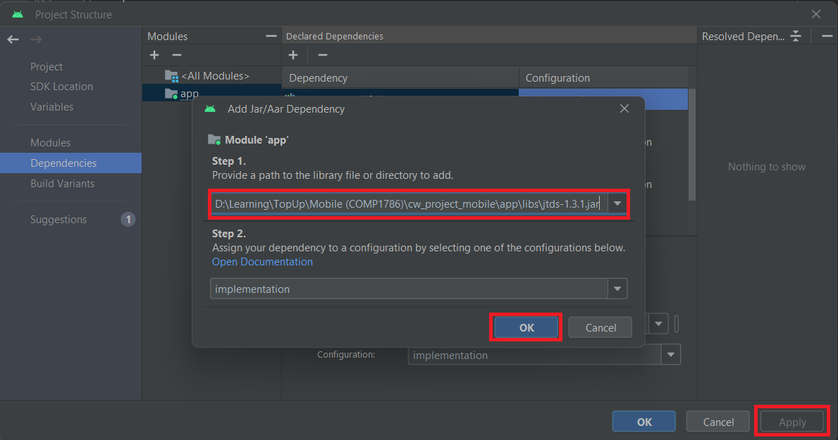

Figure 85. Paste the path just copy before

Step 4: Check the library.

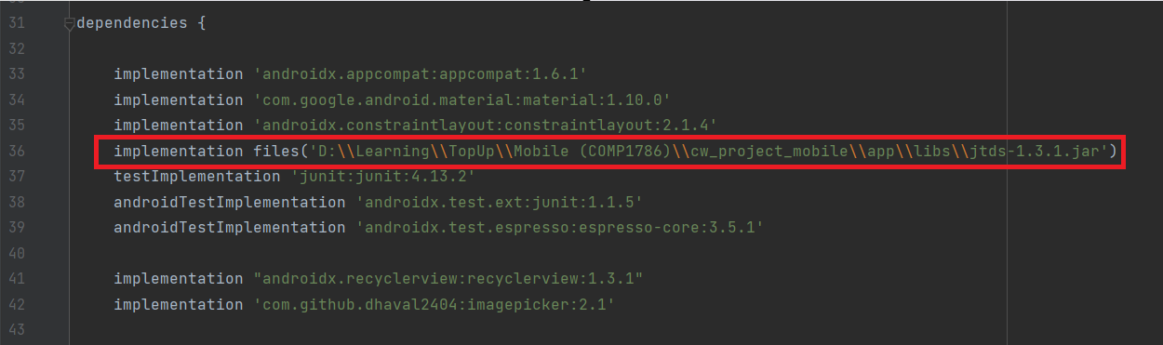

Figure 86. JTDS that applied succeed

Now, the jtds-1.3.1 is implemented.

Next, we will create a class DatabaseConnect.java to connect the application to the SQL Server.

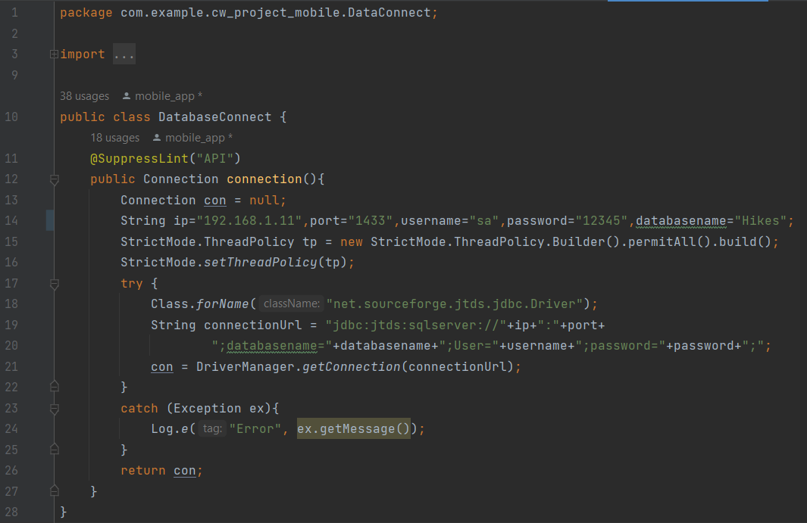

Figure 87. Connect database

Now, we connect the SQL Server to our project successfully.